(Football Association Wales)
(Date Published)
July 2020

Football Association Wales
Safeguarding Adults Policy



Person Centred Safeguarding

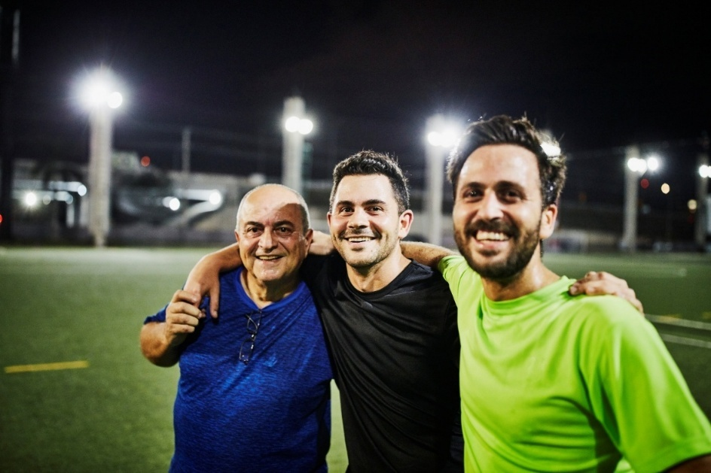
"I need to feel safe when I'm playing. When I feel safe, I can enjoy the game more."
"Knowing there are staff and coaches who are trained in safeguarding and listen."
"It’s important that I feel comfortable with my teammates and the coach. If I feel safe and respected, I can focus on playing my best. ‘’
"I like when we have clear rules about what’s okay and not okay in the game.”’
"Feeling safe is a big part of why I like to play football."
Consultation groups April 2025

Football Association Wales
Safeguarding Adults Policy

Statement from the CEO of the Football Association of Wales (FAW)

“At the Football Association of Wales (FAW), we are dedicated to ensuring a safe and supportive environment for everyone involved in football. We prioritise the well-being of all, particularly adults at risk, and work to uphold the highest safeguarding standards across the sport. Our commitment to safeguarding is reflected in our policies, training, and the ongoing support we provide to clubs and communities throughout Wales.”

Noel Mooney Chief Executive

Policy Owner: Football Association Wales
Policy approved by: FAW Board
Date Policy approved: 27/05/25
Next review Date: 27/06/25

Version Control
Version | Date | Description of Changes/collaboration | Author/Editor | Date sent back
1.0 | 12/03/25 | Created | Natalie Chamberlain (Senior Safeguarding and Player Welfare Manager) | N/A
1.0 | 12/04/25 | Sent to legal Counsel for feedback | Nick Lewis | 14/04/25
1.0 | 12/04/25 | Sent to Senior Equality, Diversity, Inclusion & Sustainability Manager for feedback – feedback by email | Carys Ingram and Jason Webber | 08/05/25
1.0 | 12/04/25 | Sent to Grassroots and Disability Inclusion Manager for feedback – feedback by email | Dai Carpenter | 10/05/25
1.0 | 12/04/25 | Sent to Jodi Evans Anne Craft Trust – verbal feedback face to face meeting – change Adults and Risk to Adults | Jodie Evans | 7/5/25
1.0 | 12/04/25 | Sent to Noel Mooney for a quote | Noel Mooney | 14/03/25
2.0 | 15/5/25 | Sent to Gaynor McKeown Independent Safeguarding Advisor to the Board | Gaynor McKeown | 15/5/25
2.0 | 20/05 | Sent to Board for approval | Approved by FAW Board 27/05/25 | 27/05/25

Table of Contents

Section 1
Introduction 6 Policy Statement 7
Purpose 8
Scope 8
Commitments 8
Implementation 10
Safegaurding Children 11

Section 2
Supporting Information
Key Points 11

Safeguarding Adults Legislation 12
Definition of an Adult at Risk 13
Signs and Indicators of Abuse and Neglect ………………………16
Sexual Harassment and Violence Against Women and Girls…….17
Person in a Position of Trust………………………………………………………………………………18
Wellbeing Principle 21
Person Centred Safeguarding/ Making Safeguarding Personal 21
Mental Capacity and Decision Making 23
Recording and Information Sharing 25
Multi-Agency Working 27

Section 3: Appendices
Appendix 1 – FAW Safeguarding Team 29
Appendix 2 – FAW Safeguarding Panel 30
Appendix 3 – Sources of Information and Support 31

Introduction
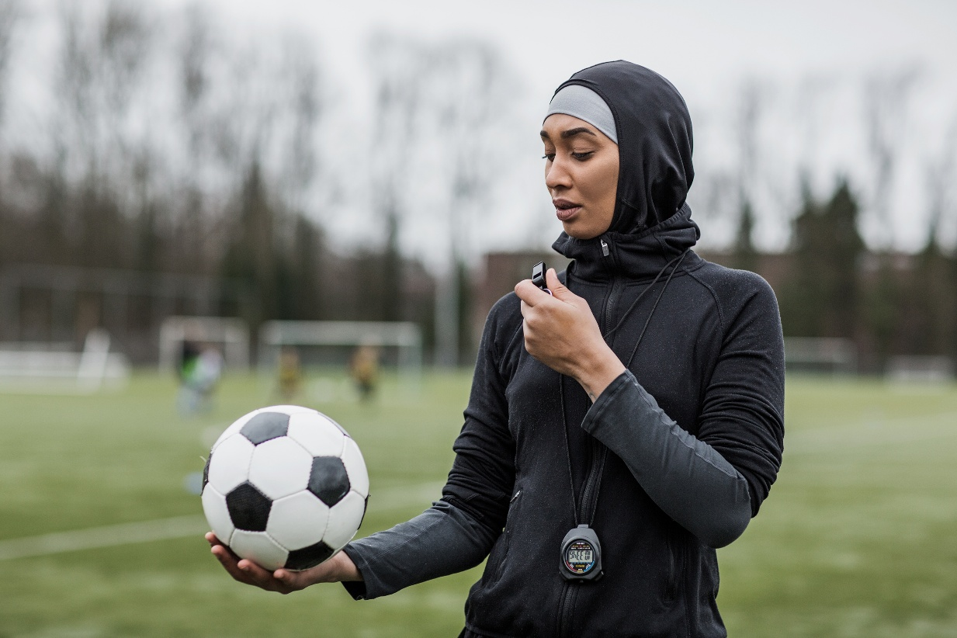
The FAW is committed to Safeguarding Adults in line with national legislation and relevant national and local guidelines.
We will safeguard adults by ensuring that our activities are delivered in a way which keeps all adults safe.
The FAW is committed to creating a culture of zero-tolerance of harm to adults which necessitates: the recognition of adults who may be at risk and the circumstances which may increase risk; knowing how adult abuse, exploitation or neglect manifests itself; and being willing to report safeguarding concerns.
This extends to recognising and reporting harm experienced anywhere, including within our activities, within other organised community or voluntary activities, in the community, in the person’s own home and in any care setting.
The FAW is committed to best safeguarding practice and to upholding the rights of all adults to live a life free from harm, abuse, exploitation, and neglect.

Policy Statement

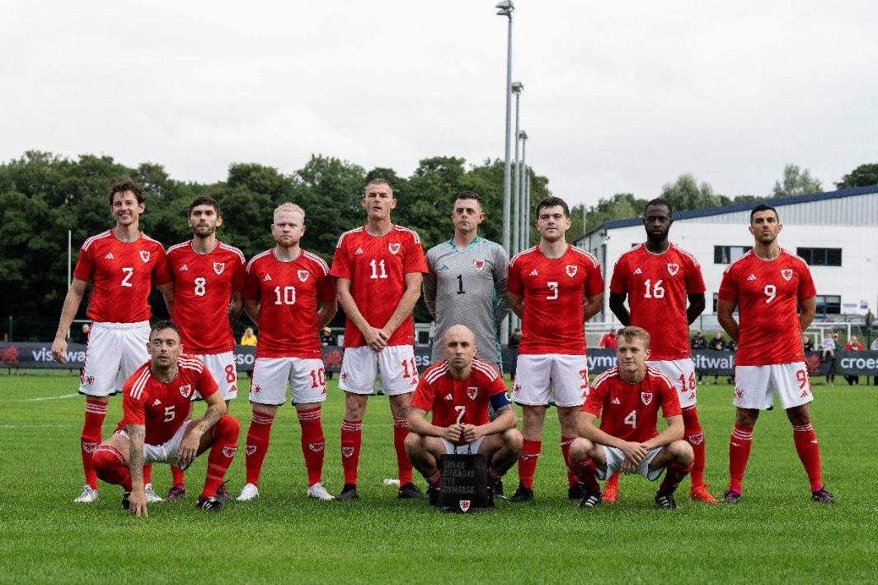
The FAW believes everyone has the right to live free from abuse or neglect regardless of age, ability or disability, sex, race, religion, ethnic origin, sexual orientation, marital or gender status.
The FAW is committed to creating and maintaining a safe and positive environment and an open, listening culture where people feel able to share concerns without fear of retribution.
The FAW acknowledges that safeguarding is everybody’s responsibility and is committed to preventing abuse and neglect through safeguarding the welfare of all adults involved.
The FAW recognises that health, well-being, ability, disability and the need for care and support can affect a person’s resilience. We recognise that some people experience barriers, for example, to communication in raising concerns or seeking help. We recognise that these factors can vary at different points in people’s lives.
Actions taken by the FAW will be consistent with the principles of adult safeguarding ensuring that any action taken is prompt, proportionate and that it includes and respects the voice of the adult concerned.
communication in raising concerns or seeking help. We recognise that these factors can vary at different points in people’s lives.
The FAW recognises that there is a legal framework within which sport need to work to safeguard adults who have needs for care and support and for protecting those who are unable to take action to protect themselves and will act in accordance with the relevant safeguarding adult legislation and with local statutory safeguarding procedures.

Purpose
The purpose of this policy is to demonstrate the commitment of the FAW to safeguarding adults and to ensure that everyone involved in the FAW is aware of:
- The legislation, policy and procedures for safeguarding adults.
- Their role and responsibility for safeguarding adults.
- What to do or who to speak to if they have a concern relating to the welfare or wellbeing of an adult playing football within Wales.

Scope
This safeguarding adult policy and associated procedures apply to all individuals involved in the FAW including Board members, Council members, staff, coaches, volunteers, and members and our partners and to all concerns about the safety of adults whilst taking part in our organisation, its activities and in the wider community.
We expect our partner organisations and members to adopt and demonstrate their commitment to the principles and practice as set out in this Safeguarding Adults Policy and associated procedures.

Commitments
To implement this policy the FAW will ensure that:
- Everyone involved with the FAW is aware of the safeguarding adult procedures and knows what to do and who to contact if they have a concern relating to the welfare or wellbeing of an adult.
- Any concern that an adult is not safe is taken seriously, responded to promptly, and
followed up in line with the FAW Safeguarding Adults Policy and Procedures.
- The well-being of those at risk of harm will be put first and the adult is actively supported to communicate their views and the outcomes they want to achieve.
- Those adults will be respected and supported unless there are overriding reasons not to (see the Safeguarding Adults Procedures).
- Any actions taken will respect the rights and dignity of all those involved and be proportionate to the risk of harm.
- Confidential, detailed and accurate records of all safeguarding concerns are maintained and securely stored in line with our Data Protection Policy and Procedures.
- The FAW acts in accordance with best practice advice, from UK Sport, Sport Wales, CPSU, and the Ann Craft Trust.
- The FAW will cooperate with the Police and the relevant Local Authorities in taking action to safeguard an adult.
  - All Board members, Council members, staff, officials and volunteers understand their role and responsibility for safeguarding adults and have completed and are up to date with safeguarding adult training and learning opportunities appropriate for their role.
  - The FAW uses safe recruitment practices and continually assesses the suitability of volunteers and staff to prevent the employment/deployment of unsuitable individuals in this organisation and within the sporting community.
  - The FAW shares information about anyone found to be a risk to adults with the appropriate bodies. For example: Disclosure and Barring Service, Police, Local Authority/Social Services.
  - When planning activities and events the FAW includes an assessment of, and risk to, the safety of all adults from abuse and neglect and designates a person who will be in attendance as a safeguarding lead for that event.
  - Actions taken under this policy are reviewed by the Board and senior management team on an annual basis.
  - This policy, related policies and the Safeguarding Adults Procedures are reviewed no less than on a two-yearly basis and whenever there are changes in relevant legislation and/or government guidance as required by the Local Safeguarding Board, UK Sport and Sport Wales because of any other significant change or event.
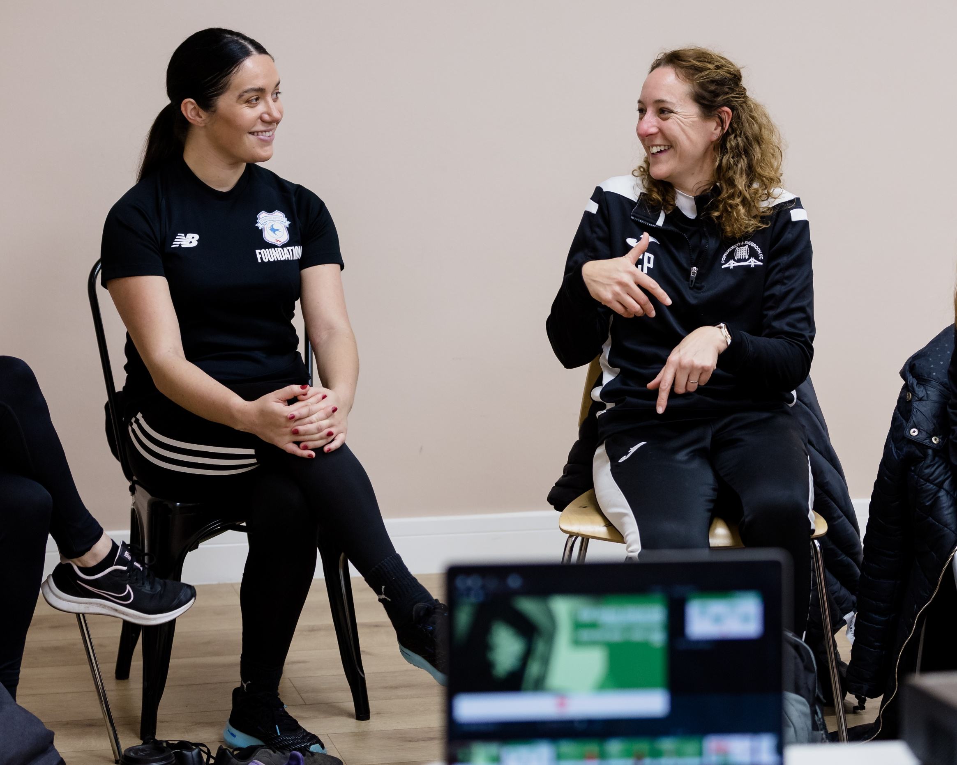
Implementation

The FAW is committed to developing and maintaining its capability to implement this policy and procedures.
To do so the following will be in place:
A clear line of accountability within the organisation for the safety and welfare of all adults.
Access to relevant legal and professional advice.
A process for forming a Case Management Working Group on a case-by-case basis within clear terms of reference.
A standing Case Management Group with an appointed Chair.
FAW Safeguarding Team
Regular management reports to the Board detailing how risks to adult safeguarding are being addressed and how any reports have been addressed.
Safeguarding adult procedures that deal effectively with any concerns of abuse or neglect, including those caused through poor practice.
A delegated Safeguarding Lead for specified events/trips/camps/competitions.
Arrangements to work effectively with other relevant organisations to safeguard and promote the welfare of adults, including arrangements for sharing information.
Codes of conduct for Board members, Council members, staff, coaches, officials, volunteers and Members and other relevant individuals that specify zero tolerance of abuse in any form.
Risk assessments that specifically include safeguarding of adults.
Policies and procedures that address the following areas and which are consistent with this Safeguarding Adults policy:

- Bullying and harassment
- Social Media
- Equality, diversity and inclusion
- Safe activities risk assessments
- Code of Conducts and a process for breach of these - Staff, Coaches, Officials, Volunteers, Participants/Members, Carers/Personal Assistants, Fans
- Discipline and grievance
- Concerns, Complaints and Compliments
- Whistleblowing
- Safe recruitment and selection (staff and volunteers)
- Contract compliance
- Information policy, data protection and information sharing

Section 2: Supporting Information

Section 2: Supporting Information

Section 2: Supporting Information

Section 2: Supporting Information

Section 2: Supporting Information

Section 2: Supporting Information

Section 2: Supporting Information

Section 2: Supporting Information

Section 2: Supporting Information

Section 2: Supporting Information

Section 2: Supporting Information

Section 2: Supporting Information

Section 2: Supporting Information

Section 2: Supporting Information

Section 2: Supporting Information

Section 2: Supporting Information

Section 2: Supporting Information

Section 2: Supporting Information

Section 2: Supporting Information

Section 2: Supporting Information

Section 2: Supporting Information

Section 2: Supporting Information

Section 2: Supporting Information

Section 2: Supporting Information

Section 2: Supporting Information

Section 2: Supporting Information

Section 2: Supporting Information

Section 2: Supporting Information

Section 2: Supporting Information

Section 2: Supporting Information

Section 2: Supporting Information

Section 2: Supporting Information

Section 2: Supporting Information

Section 2: Supporting Information

Section 2: Supporting Information

Section 2: Supporting Information

Section 2: Supporting Information

Section 2: Supporting Information

Section 2: Supporting Information

Section 2: Supporting Information

Section 2: Supporting Information

Section 2: Supporting Information

Section 2: Supporting Information

Section 2: Supporting Information

Section 2: Supporting Information

Section 2: Supporting Information

Section 2: Supporting Information

Section 2: Supporting Information

Section 2: Supporting Information

Section 2: Supporting Information

Section 2: Supporting Information

Section 2: Supporting Information

Section 2: Supporting Information

Section 2: Supporting Information

Section 2: Supporting Information

Section 2: Supporting Information

Section 2: Supporting Information

Section 2: Supporting Information

Section 2: Supporting Information

Section 2: Supporting Information

Section 2: Supporting Information

Section 2: Supporting Information

Section 2: Supporting Information

Section 2: Supporting Information

Section 2: Supporting Information

Section 2: Supporting Information

Section 2: Supporting Information

Section 2: Supporting Information

Section 2: Supporting Information

Section 2: Supporting Information

Section 2: Supporting Information

Section 2: Supporting Information

Section 2: Supporting Information

Section 2: Supporting Information

Section 2: Supporting Information

Section 2: Supporting Information

Section 2: Supporting Information

Section 2: Supporting Information

Section 2: Supporting Information

Section 2: Supporting Information

Section 2: Supporting Information

Section 2: Supporting Information

Section 2: Supporting Information

Section 2: Supporting Information

Section 2: Supporting Information

Section 2: Supporting Information

Section 2: Supporting Information

Section 2: Supporting Information

Section 2: Supporting Information

Section 2: Supporting Information

Section 2: Supporting Information

Section 2: Supporting Information

Section 2: Supporting Information

Section 2: Supporting Information

Section 2: Supporting Information

Section 2: Supporting Information

Section 2: Supporting Information

Section 2: Supporting Information

Section 2: Supporting Information

Section 2: Supporting Information

Section 2: Supporting Information

Section 2: Supporting Information

Section 2: Supporting Information

Section 2: Supporting Information

Section 2: Supporting Information

Section 2: Supporting Information

Section 2: Supporting Information

Section 2: Supporting Information

Section 2: Supporting Information

Section 2: Supporting Information

Section 2: Supporting Information

Section 2: Supporting Information

Section 2: Supporting Information

Section 2: Supporting Information

Section 2: Supporting Information

Section 2: Supporting Information

Section 2: Supporting Information

Section 2: Supporting Information

Section 2: Supporting Information

Section 2: Supporting Information

Section 2: Supporting Information

Section 2: Supporting Information

Section 2: Supporting Information

Section 2: Supporting Information

Section 2: Supporting Information

Section 2: Supporting Information

Section 2: Supporting Information

Section 2: Supporting Information

Key Points

- There is a legal duty on Local Authorities to provide support to ‘adults at risk’.
- Adults at risk are defined in legislation and the criteria applied differs between each home nation.
- The safeguarding legislation applies to all forms of abuse that harm a person’s well-being.
- The law provides a framework for good practice in safeguarding that makes the overall well-being of the adult at risk a priority of any intervention.
- The law in all four home nations emphasises the importance of person-centred safeguarding.
- The law provides a framework for making decisions on behalf of adults who can’t make decisions for themselves (Mental Capacity).
- The law provides a framework for sports organisations to share concerns they have about adults at risk with the local authority.
- The law provides a framework for all organisations to share information and cooperate to protect adults at risk.

Safeguarding Adults Legislation

Safeguarding Adults in all home nations is compliant with United Nations directives on the rights of disabled people and commitments to the rights of older people. It is covered by:
- The Human Rights Act 1998
- The Data Protection Act 2018
- Equalities Act 2010
- General Data Protection Regulations 2018
The practices and procedures within this policy are based on the relevant legislation and government guidance.
- Wales - Social Services and Well Being Act 2014
Wales Safeguarding Procedures 2019
Many other pieces of UK and home nation legislation also affect adult safeguarding.
These include legislation about different forms of abuse and those that govern information sharing. For example, legislation dealing with
- Murder/attempted murder
- Physical Assault
- Sexual Offences
- Domestic Abuse/Coercive control
- Forced Marriage
- Female Genital Mutilation
- Theft and Fraud.
Each home nation also has legislation about the circumstances in which decisions can be made on behalf of an adult who is unable to make decisions for themselves:
- England and Wales - Mental Capacity Act 2005

- There are specific offences applying to the mistreatment of and sexual offences against adults who do not have Mental Capacity and specific offences where mistreatment is carried out by a person who is employed as a carer: e.g. wilful neglect and wilful mistreatment.
The Safeguarding Adults legislation creates specific responsibilities on Local Authorities, Health, and the Police to provide additional protection from abuse and neglect to Adults at Risk.
When a Local Authority has reason to believe there is an adult at risk, they have a responsibility to find out more about the situation and decide what actions need to be taken to support the adult. In Scotland and Wales, the Local Authority can gain access to an adult to find out if they are at risk of harm for example, if that access is being blocked by another person.
The actions that need to be taken might be by the Local Authority (usually social services) and/or by other agencies, for example the Police and Health. A sporting organisation may need to take action as part of safeguarding an adult, for example, to use the disciplinary procedures in relation to a member of staff or member who has been reported to be harming a participant. The Local Authority role includes having multi-agency procedures which coordinate the actions taken by different organisations.

Definition of an Adult at Risk
An adult at risk is an individual aged 18 years and over who:
- Is experiencing or is at risk of abuse or neglect,
- Has needs for care and support (whether or not the authority is meeting any of those needs), and
- As a result of those needs is unable to protect himself or herself against the abuse or neglect or the risk of it.
Social Services and Well-being (Wales) Act 20144
It is important to note:
- the use of the term ‘at risk’ means that actual abuse or neglect does not need to occur before practitioners intervene, rather early interventions to protect an adult at risk should be considered to prevent actual abuse and neglect;
- the three conditions necessary to demonstrate an adult is at risk of abuse or neglect ensures that protection is provided to those with care and support needs who also require actions to secure the individual’s safety in the future because they are unable to protect themselves.
- that the abuse of adults deemed to be ‘at risk’ is often linked to their circumstances rather than the characteristics of the people experiencing harm.
- risk of abuse or neglect may be the consequence of one concern or a result of cumulative factors.
Abuse is a violation of an individual’s human and civil rights by another person or persons. It can occur in any relationship and may result in significant harm to, or exploitation of, the person subjected to it. Any or all of the following types of abuse may be perpetrated as the result of deliberate intent, negligence, omission or ignorance.
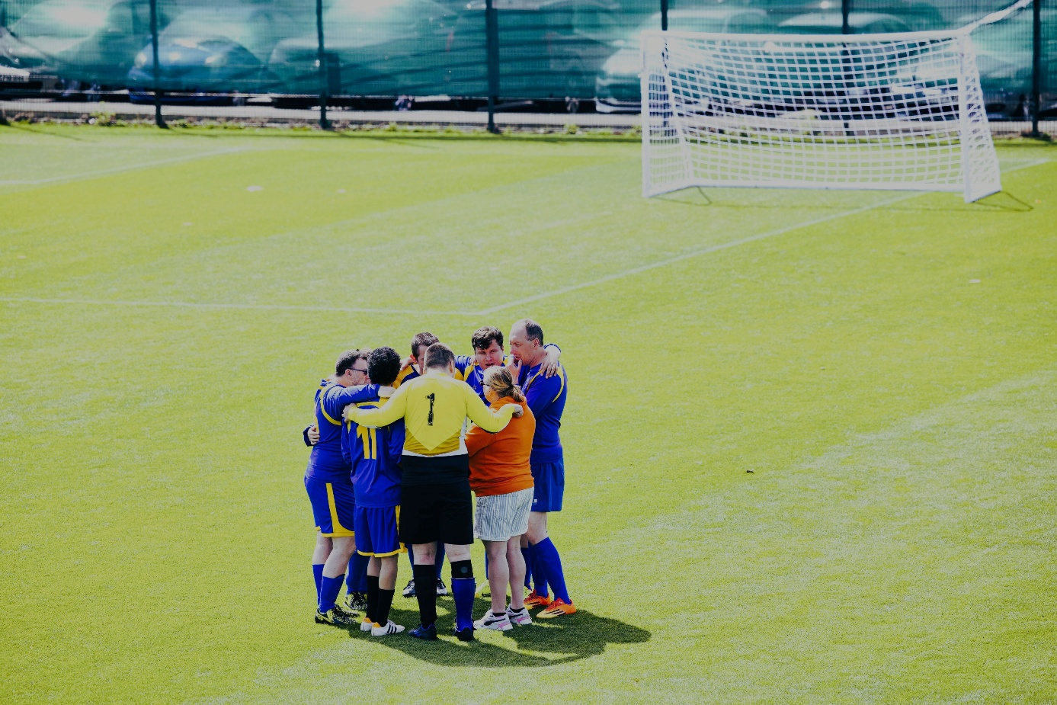

There are different types and patterns of abuse and neglect and different circumstances in which they may take place.
Physical Abuse: Inflicting physical harm or mistreatment on another, it may or may not result in injury, such as hitting, slapping, pushing, or other forms of physical violence.
Sexual Abuse and violence: Any form of sexual activity or behaviour forced upon an individual without their consent, including assault, exploitation, or harassment. It can also include non-contact sexual activities.
Neglect: The failure to provide essential care and support for an individual’s basic needs, including food, shelter, clothing, or medical attention, leading to harm or deterioration of their well-being.
Self-Neglect: When an individual fails to care for themselves or meet their basic needs, leading to personal harm, often due to mental illness, disability, or age.
Financial Abuse: The illegal or unauthorised use of someone’s money or assets, such as coercing them to hand over financial control or exploiting them for financial gain.
Psychological and Emotional Abuse: Behaviours that cause emotional harm, such as intimidation, threats, manipulation, isolation, or verbal abuse, which affect someone's mental well-being.

Abuse can take place in any relationship and there are many contexts in which abuse might take place, e.g. Institutional abuse, Domestic Abuse, Forced Marriage, Human Trafficking, Modern Slavery, Sexual Exploitation, County Lines, Radicalisation, Hate Crime, Mate Crime, Cyber bullying, Scams.
Abuse can take place within a sporting context and the person causing harm might be any other person. For example: a member of staff, a coach, a volunteer, a participant or a fan.


Some examples of abuse within sport include:
- Harassment of a participant because of their (perceived) disability or other protected characteristics.
- Not meeting the needs of the participant e.g. training without a necessary break.
- A coach intentionally striking an athlete
- One elite participant controlling another athlete with threats of withdrawal from their partnership
- An official who sends unwanted sexually explicit text messages to a participant with learning disabilities.
- A participant threatens another participant with physical harm and persistently blames them for poor performance.
Abuse or neglect outside sport could be carried out by:
- A spouse, partner or family member
- Neighbours or residents
- Friends, acquaintances or strangers
- People who deliberately exploit adults they perceive as vulnerable
- Paid staff, professionals or volunteers providing care and support
- Often the perpetrator is known to the adult and may be in a position of trust and/or power.

Signs and Indicators of Abuse and Neglect
An adult may confide to a member of staff, coach, volunteer or another participant that they are experiencing abuse inside or outside of the organisation’s setting. Similarly, others may suspect that this is the case.
There are many signs and indicators that may suggest someone is being abused or neglected. There may be other explanations, but they should not be ignored. The signs and symptoms include but are not limited to:
- Unexplained bruises or injuries – or lack of medical attention when an injury is present.
- Person has belongings or money going missing.
- Person is not attending / no longer enjoying their sessions. You may notice that a participant in a team has been missing from practice sessions and is not responding to reminders from team members or coaches.
- Someone losing or gaining weight / an unkempt appearance. This could be a player whose appearance becomes unkempt, does not wear suitable sports kit and there is a deterioration in hygiene.
- A change in the behaviour or confidence of a person. For example, a participant may be looking quiet and withdrawn when their brother comes to collect them from sessions in contrast to their personal assistant whom they greet with a smile.
- Self-harm.
- A fear of a particular group of people or individual.
- A parent/carer always speaks for the person and doesn’t allow them to make their own choices.
- They may tell you / another person they are being abused – i.e. a disclosure.
- Unexplained bruises or injuries – or lack of medical attention when an injury is present.
- Person has belongings or money going missing.
- Person is not attending / no longer enjoying their sessions. You may notice that a participant in a team has been missing from practice sessions and is not responding to reminders from team members or coaches.
- Someone losing or gaining weight / an unkempt appearance. This could be a player whose appearance becomes unkempt, does not wear suitable sports kit and there is a deterioration in hygiene.
- A change in the behaviour or confidence of a person. For example, a participant may be looking quiet and withdrawn when their brother comes to collect them from sessions in contrast to their personal assistant whom they greet with enthusiasm.

Sexual Harassment and Violence Against Women and Girls (VAWG)
FAW’s Commitment to Prevention and Action
The FAW, Area Associations, Leagues and Clubs must commit to creating a safe, inclusive, and respectful environment for all participants, with a zero-tolerance approach to sexual harassment and violence against women and girls (VAWG). These behaviours are not only unacceptable—they can be contravening codes of conduct, but they could also be safeguarding concerns and, in many cases, criminal offences.
Understanding the Issue
Sexual harassment and VAWG can take many forms, including unwanted physical contact, inappropriate or sexualised language, coercive control, threats, stalking, and online abuse. These behaviours can occur in person or through digital platforms. Whilst others are affected and will always be dealt with in exactly the same way we recognise that women and girls, particularly those with additional vulnerabilities, are disproportionately affected by such abuse.

Our Priority
Addressing and preventing sexual harassment and VAWG is a priority for the FAW. We will:
- Ensure all staff, volunteers, and participants receive training to recognise, prevent, and appropriately respond to incidents.
- Collaborate with local police and safeguarding partners to ensure a coordinated and effective response where needed.
Empowering and Protecting
We aim to foster a culture where everyone - regardless of gender - feels empowered to speak up, supported when they do, and protected from harm. Football is a space where safety and dignity are non-negotiable.

A Position of Trust
A Position of Trust refers to any role in which an adult (such as a coach, manager, volunteer, or official) is responsible for the care, supervision, or support of adults. These roles inherently carry an imbalance of power and influence.
Individuals in a Position of Trust must not engage in any behavior or relationship—whether physical, emotional, or sexual—that exploits or abuses this power dynamic.
Key Principles
- The welfare and dignity of the adult must be the primary consideration in all interactions.
- Relationships of trust must never be used for personal gain or gratification.
- Consent may be compromised by the imbalance of power—therefore, any sexual or intimate relationship with an adult at risk may be viewed as a breach of professional boundaries, even if the adult appears to consent.
All staff and volunteers must always maintain professional boundaries and act as positive role models
The Social Services and Well-being (Wales) Act 2014 places a duty on all relevant individuals and organisations to report and respond to the abuse or neglect of adults at risk. This includes breaches of professional boundaries by those in positions of authority.

FAW and Club Expectations
Even in the absence of a specific legal offence, the FAW and affiliated clubs take the misuse of a position of trust extremely seriously. All individuals in such roles are expected to:
- Maintain professional boundaries at all times.
- Never use their role to form or pursue sexual or inappropriate emotional relationships with adults at risk.
- Recognise that power and influence can impair an adult’s ability to freely give consent.
- Understand that any such relationship may be viewed as an abuse of trust, regardless of apparent consent.

Reporting Concerns
Any concerns or suspicions regarding a breach of trust or inappropriate conduct must be reported immediately to the club's Designated Safeguarding Officer or via the FAW’s safeguarding procedures. Where appropriate, concerns will be referred to statutory agencies (e.g., Social Services or the Police).


“The success of sport, in terms of helping people achieve their potential, making the most of existing talent, and attracting new people to sport
relies on putting people – their safety, wellbeing and welfare – at the centre of what sport does. ‘’

“The success of sport, in terms of helping people achieve their potential, making the most of existing talent, and attracting new people to sport
relies on putting people – their safety, wellbeing and welfare – at the centre of what sport does. ‘’

“The success of sport, in terms of helping people achieve their potential, making the most of existing talent, and attracting new people to sport
relies on putting people – their safety, wellbeing and welfare – at the centre of what sport does. ‘’

“The success of sport, in terms of helping people achieve their potential, making the most of existing talent, and attracting new people to sport
relies on putting people – their safety, wellbeing and welfare – at the centre of what sport does. ‘’

“The success of sport, in terms of helping people achieve their potential, making the most of existing talent, and attracting new people to sport
relies on putting people – their safety, wellbeing and welfare – at the centre of what sport does. ‘’

“The success of sport, in terms of helping people achieve their potential, making the most of existing talent, and attracting new people to sport
relies on putting people – their safety, wellbeing and welfare – at the centre of what sport does. ‘’

“The success of sport, in terms of helping people achieve their potential, making the most of existing talent, and attracting new people to sport
relies on putting people – their safety, wellbeing and welfare – at the centre of what sport does. ‘’

“The success of sport, in terms of helping people achieve their potential, making the most of existing talent, and attracting new people to sport
relies on putting people – their safety, wellbeing and welfare – at the centre of what sport does. ‘’

“The success of sport, in terms of helping people achieve their potential, making the most of existing talent, and attracting new people to sport
relies on putting people – their safety, wellbeing and welfare – at the centre of what sport does. ‘’

“The success of sport, in terms of helping people achieve their potential, making the most of existing talent, and attracting new people to sport
relies on putting people – their safety, wellbeing and welfare – at the centre of what sport does. ‘’

“The success of sport, in terms of helping people achieve their potential, making the most of existing talent, and attracting new people to sport
relies on putting people – their safety, wellbeing and welfare – at the centre of what sport does. ‘’

“The success of sport, in terms of helping people achieve their potential, making the most of existing talent, and attracting new people to sport
relies on putting people – their safety, wellbeing and welfare – at the centre of what sport does. ‘’

“The success of sport, in terms of helping people achieve their potential, making the most of existing talent, and attracting new people to sport
relies on putting people – their safety, wellbeing and welfare – at the centre of what sport does. ‘’

“The success of sport, in terms of helping people achieve their potential, making the most of existing talent, and attracting new people to sport
relies on putting people – their safety, wellbeing and welfare – at the centre of what sport does. ‘’

“The success of sport, in terms of helping people achieve their potential, making the most of existing talent, and attracting new people to sport
relies on putting people – their safety, wellbeing and welfare – at the centre of what sport does. ‘’

“The success of sport, in terms of helping people achieve their potential, making the most of existing talent, and attracting new people to sport
relies on putting people – their safety, wellbeing and welfare – at the centre of what sport does. ‘’

“The success of sport, in terms of helping people achieve their potential, making the most of existing talent, and attracting new people to sport
relies on putting people – their safety, wellbeing and welfare – at the centre of what sport does. ‘’

“The success of sport, in terms of helping people achieve their potential, making the most of existing talent, and attracting new people to sport
relies on putting people – their safety, wellbeing and welfare – at the centre of what sport does. ‘’

“The success of sport, in terms of helping people achieve their potential, making the most of existing talent, and attracting new people to sport
relies on putting people – their safety, wellbeing and welfare – at the centre of what sport does. ‘’

“The success of sport, in terms of helping people achieve their potential, making the most of existing talent, and attracting new people to sport
relies on putting people – their safety, wellbeing and welfare – at the centre of what sport does. ‘’

“The success of sport, in terms of helping people achieve their potential, making the most of existing talent, and attracting new people to sport
relies on putting people – their safety, wellbeing and welfare – at the centre of what sport does. ‘’

“The success of sport, in terms of helping people achieve their potential, making the most of existing talent, and attracting new people to sport
relies on putting people – their safety, wellbeing and welfare – at the centre of what sport does. ‘’

“The success of sport, in terms of helping people achieve their potential, making the most of existing talent, and attracting new people to sport
relies on putting people – their safety, wellbeing and welfare – at the centre of what sport does. ‘’

“The success of sport, in terms of helping people achieve their potential, making the most of existing talent, and attracting new people to sport
relies on putting people – their safety, wellbeing and welfare – at the centre of what sport does. ‘’

“The success of sport, in terms of helping people achieve their potential, making the most of existing talent, and attracting new people to sport
relies on putting people – their safety, wellbeing and welfare – at the centre of what sport does. ‘’

“The success of sport, in terms of helping people achieve their potential, making the most of existing talent, and attracting new people to sport
relies on putting people – their safety, wellbeing and welfare – at the centre of what sport does. ‘’

“The success of sport, in terms of helping people achieve their potential, making the most of existing talent, and attracting new people to sport
relies on putting people – their safety, wellbeing and welfare – at the centre of what sport does. ‘’

“The success of sport, in terms of helping people achieve their potential, making the most of existing talent, and attracting new people to sport
relies on putting people – their safety, wellbeing and welfare – at the centre of what sport does. ‘’

“The success of sport, in terms of helping people achieve their potential, making the most of existing talent, and attracting new people to sport
relies on putting people – their safety, wellbeing and welfare – at the centre of what sport does. ‘’

“The success of sport, in terms of helping people achieve their potential, making the most of existing talent, and attracting new people to sport
relies on putting people – their safety, wellbeing and welfare – at the centre of what sport does. ‘’

“The success of sport, in terms of helping people achieve their potential, making the most of existing talent, and attracting new people to sport
relies on putting people – their safety, wellbeing and welfare – at the centre of what sport does. ‘’

“The success of sport, in terms of helping people achieve their potential, making the most of existing talent, and attracting new people to sport
relies on putting people – their safety, wellbeing and welfare – at the centre of what sport does. ‘’

“The success of sport, in terms of helping people achieve their potential, making the most of existing talent, and attracting new people to sport
relies on putting people – their safety, wellbeing and welfare – at the centre of what sport does. ‘’

“The success of sport, in terms of helping people achieve their potential, making the most of existing talent, and attracting new people to sport
relies on putting people – their safety, wellbeing and welfare – at the centre of what sport does. ‘’

“The success of sport, in terms of helping people achieve their potential, making the most of existing talent, and attracting new people to sport
relies on putting people – their safety, wellbeing and welfare – at the centre of what sport does. ‘’

“The success of sport, in terms of helping people achieve their potential, making the most of existing talent, and attracting new people to sport
relies on putting people – their safety, wellbeing and welfare – at the centre of what sport does. ‘’

“The success of sport, in terms of helping people achieve their potential, making the most of existing talent, and attracting new people to sport
relies on putting people – their safety, wellbeing and welfare – at the centre of what sport does. ‘’

“The success of sport, in terms of helping people achieve their potential, making the most of existing talent, and attracting new people to sport
relies on putting people – their safety, wellbeing and welfare – at the centre of what sport does. ‘’

“The success of sport, in terms of helping people achieve their potential, making the most of existing talent, and attracting new people to sport
relies on putting people – their safety, wellbeing and welfare – at the centre of what sport does. ‘’

“The success of sport, in terms of helping people achieve their potential, making the most of existing talent, and attracting new people to sport
relies on putting people – their safety, wellbeing and welfare – at the centre of what sport does. ‘’

“The success of sport, in terms of helping people achieve their potential, making the most of existing talent, and attracting new people to sport
relies on putting people – their safety, wellbeing and welfare – at the centre of what sport does. ‘’

“The success of sport, in terms of helping people achieve their potential, making the most of existing talent, and attracting new people to sport
relies on putting people – their safety, wellbeing and welfare – at the centre of what sport does. ‘’

“The success of sport, in terms of helping people achieve their potential, making the most of existing talent, and attracting new people to sport
relies on putting people – their safety, wellbeing and welfare – at the centre of what sport does. ‘’

“The success of sport, in terms of helping people achieve their potential, making the most of existing talent, and attracting new people to sport
relies on putting people – their safety, wellbeing and welfare – at the centre of what sport does. ‘’

“The success of sport, in terms of helping people achieve their potential, making the most of existing talent, and attracting new people to sport
relies on putting people – their safety, wellbeing and welfare – at the centre of what sport does. ‘’

“The success of sport, in terms of helping people achieve their potential, making the most of existing talent, and attracting new people to sport
relies on putting people – their safety, wellbeing and welfare – at the centre of what sport does. ‘’

“The success of sport, in terms of helping people achieve their potential, making the most of existing talent, and attracting new people to sport
relies on putting people – their safety, wellbeing and welfare – at the centre of what sport does. ‘’

“The success of sport, in terms of helping people achieve their potential, making the most of existing talent, and attracting new people to sport
relies on putting people – their safety, wellbeing and welfare – at the centre of what sport does. ‘’

“The success of sport, in terms of helping people achieve their potential, making the most of existing talent, and attracting new people to sport
relies on putting people – their safety, wellbeing and welfare – at the centre of what sport does. ‘’

“The success of sport, in terms of helping people achieve their potential, making the most of existing talent, and attracting new people to sport
relies on putting people – their safety, wellbeing and welfare – at the centre of what sport does. ‘’

“The success of sport, in terms of helping people achieve their potential, making the most of existing talent, and attracting new people to sport
relies on putting people – their safety, wellbeing and welfare – at the centre of what sport does. ‘’

“The success of sport, in terms of helping people achieve their potential, making the most of existing talent, and attracting new people to sport
relies on putting people – their safety, wellbeing and welfare – at the centre of what sport does. ‘’

“The success of sport, in terms of helping people achieve their potential, making the most of existing talent, and attracting new people to sport
relies on putting people – their safety, wellbeing and welfare – at the centre of what sport does. ‘’

“The success of sport, in terms of helping people achieve their potential, making the most of existing talent, and attracting new people to sport
relies on putting people – their safety, wellbeing and welfare – at the centre of what sport does. ‘’

“The success of sport, in terms of helping people achieve their potential, making the most of existing talent, and attracting new people to sport
relies on putting people – their safety, wellbeing and welfare – at the centre of what sport does. ‘’

“The success of sport, in terms of helping people achieve their potential, making the most of existing talent, and attracting new people to sport
relies on putting people – their safety, wellbeing and welfare – at the centre of what sport does. ‘’

“The success of sport, in terms of helping people achieve their potential, making the most of existing talent, and attracting new people to sport
relies on putting people – their safety, wellbeing and welfare – at the centre of what sport does. ‘’

“The success of sport, in terms of helping people achieve their potential, making the most of existing talent, and attracting new people to sport
relies on putting people – their safety, wellbeing and welfare – at the centre of what sport does. ‘’

“The success of sport, in terms of helping people achieve their potential, making the most of existing talent, and attracting new people to sport
relies on putting people – their safety, wellbeing and welfare – at the centre of what sport does. ‘’

“The success of sport, in terms of helping people achieve their potential, making the most of existing talent, and attracting new people to sport
relies on putting people – their safety, wellbeing and welfare – at the centre of what sport does. ‘’

“The success of sport, in terms of helping people achieve their potential, making the most of existing talent, and attracting new people to sport
relies on putting people – their safety, wellbeing and welfare – at the centre of what sport does. ‘’

“The success of sport, in terms of helping people achieve their potential, making the most of existing talent, and attracting new people to sport
relies on putting people – their safety, wellbeing and welfare – at the centre of what sport does. ‘’

“The success of sport, in terms of helping people achieve their potential, making the most of existing talent, and attracting new people to sport
relies on putting people – their safety, wellbeing and welfare – at the centre of what sport does. ‘’

“The success of sport, in terms of helping people achieve their potential, making the most of existing talent, and attracting new people to sport
relies on putting people – their safety, wellbeing and welfare – at the centre of what sport does. ‘’

“The success of sport, in terms of helping people achieve their potential, making the most of existing talent, and attracting new people to sport
relies on putting people – their safety, wellbeing and welfare – at the centre of what sport does. ‘’

“The success of sport, in terms of helping people achieve their potential, making the most of existing talent, and attracting new people to sport
relies on putting people – their safety, wellbeing and welfare – at the centre of what sport does. ‘’

“The success of sport, in terms of helping people achieve their potential, making the most of existing talent, and attracting new people to sport
relies on putting people – their safety, wellbeing and welfare – at the centre of what sport does. ‘’

“The success of sport, in terms of helping people achieve their potential, making the most of existing talent, and attracting new people to sport
relies on putting people – their safety, wellbeing and welfare – at the centre of what sport does. ‘’

“The success of sport, in terms of helping people achieve their potential, making the most of existing talent, and attracting new people to sport
relies on putting people – their safety, wellbeing and welfare – at the centre of what sport does. ‘’

“The success of sport, in terms of helping people achieve their potential, making the most of existing talent, and attracting new people to sport
relies on putting people – their safety, wellbeing and welfare – at the centre of what sport does. ‘’

“The success of sport, in terms of helping people achieve their potential, making the most of existing talent, and attracting new people to sport
relies on putting people – their safety, wellbeing and welfare – at the centre of what sport does. ‘’

“The success of sport, in terms of helping people achieve their potential, making the most of existing talent, and attracting new people to sport
relies on putting people – their safety, wellbeing and welfare – at the centre of what sport does. ‘’

“The success of sport, in terms of helping people achieve their potential, making the most of existing talent, and attracting new people to sport
relies on putting people – their safety, wellbeing and welfare – at the centre of what sport does. ‘’

“The success of sport, in terms of helping people achieve their potential, making the most of existing talent, and attracting new people to sport
relies on putting people – their safety, wellbeing and welfare – at the centre of what sport does. ‘’

“The success of sport, in terms of helping people achieve their potential, making the most of existing talent, and attracting new people to sport
relies on putting people – their safety, wellbeing and welfare – at the centre of what sport does. ‘’

“The success of sport, in terms of helping people achieve their potential, making the most of existing talent, and attracting new people to sport
relies on putting people – their safety, wellbeing and welfare – at the centre of what sport does. ‘’

“The success of sport, in terms of helping people achieve their potential, making the most of existing talent, and attracting new people to sport
relies on putting people – their safety, wellbeing and welfare – at the centre of what sport does. ‘’

“The success of sport, in terms of helping people achieve their potential, making the most of existing talent, and attracting new people to sport
relies on putting people – their safety, wellbeing and welfare – at the centre of what sport does. ‘’

“The success of sport, in terms of helping people achieve their potential, making the most of existing talent, and attracting new people to sport
relies on putting people – their safety, wellbeing and welfare – at the centre of what sport does. ‘’

“The success of sport, in terms of helping people achieve their potential, making the most of existing talent, and attracting new people to sport
relies on putting people – their safety, wellbeing and welfare – at the centre of what sport does. ‘’

“The success of sport, in terms of helping people achieve their potential, making the most of existing talent, and attracting new people to sport
relies on putting people – their safety, wellbeing and welfare – at the centre of what sport does. ‘’

“The success of sport, in terms of helping people achieve their potential, making the most of existing talent, and attracting new people to sport
relies on putting people – their safety, wellbeing and welfare – at the centre of what sport does. ‘’

“The success of sport, in terms of helping people achieve their potential, making the most of existing talent, and attracting new people to sport
relies on putting people – their safety, wellbeing and welfare – at the centre of what sport does. ‘’

“The success of sport, in terms of helping people achieve their potential, making the most of existing talent, and attracting new people to sport
relies on putting people – their safety, wellbeing and welfare – at the centre of what sport does. ‘’

“The success of sport, in terms of helping people achieve their potential, making the most of existing talent, and attracting new people to sport
relies on putting people – their safety, wellbeing and welfare – at the centre of what sport does. ‘’

“The success of sport, in terms of helping people achieve their potential, making the most of existing talent, and attracting new people to sport
relies on putting people – their safety, wellbeing and welfare – at the centre of what sport does. ‘’

“The success of sport, in terms of helping people achieve their potential, making the most of existing talent, and attracting new people to sport
relies on putting people – their safety, wellbeing and welfare – at the centre of what sport does. ‘’

“The success of sport, in terms of helping people achieve their potential, making the most of existing talent, and attracting new people to sport
relies on putting people – their safety, wellbeing and welfare – at the centre of what sport does. ‘’

“The success of sport, in terms of helping people achieve their potential, making the most of existing talent, and attracting new people to sport
relies on putting people – their safety, wellbeing and welfare – at the centre of what sport does. ‘’

“The success of sport, in terms of helping people achieve their potential, making the most of existing talent, and attracting new people to sport
relies on putting people – their safety, wellbeing and welfare – at the centre of what sport does. ‘’

“The success of sport, in terms of helping people achieve their potential, making the most of existing talent, and attracting new people to sport
relies on putting people – their safety, wellbeing and welfare – at the centre of what sport does. ‘’

“The success of sport, in terms of helping people achieve their potential, making the most of existing talent, and attracting new people to sport
relies on putting people – their safety, wellbeing and welfare – at the centre of what sport does. ‘’

“The success of sport, in terms of helping people achieve their potential, making the most of existing talent, and attracting new people to sport
relies on putting people – their safety, wellbeing and welfare – at the centre of what sport does. ‘’

“The success of sport, in terms of helping people achieve their potential, making the most of existing talent, and attracting new people to sport
relies on putting people – their safety, wellbeing and welfare – at the centre of what sport does. ‘’

“The success of sport, in terms of helping people achieve their potential, making the most of existing talent, and attracting new people to sport
relies on putting people – their safety, wellbeing and welfare – at the centre of what sport does. ‘’

“The success of sport, in terms of helping people achieve their potential, making the most of existing talent, and attracting new people to sport
relies on putting people – their safety, wellbeing and welfare – at the centre of what sport does. ‘’

“The success of sport, in terms of helping people achieve their potential, making the most of existing talent, and attracting new people to sport
relies on putting people – their safety, wellbeing and welfare – at the centre of what sport does. ‘’

“The success of sport, in terms of helping people achieve their potential, making the most of existing talent, and attracting new people to sport
relies on putting people – their safety, wellbeing and welfare – at the centre of what sport does. ‘’

“The success of sport, in terms of helping people achieve their potential, making the most of existing talent, and attracting new people to sport
relies on putting people – their safety, wellbeing and welfare – at the centre of what sport does. ‘’

“The success of sport, in terms of helping people achieve their potential, making the most of existing talent, and attracting new people to sport
relies on putting people – their safety, wellbeing and welfare – at the centre of what sport does. ‘’

“The success of sport, in terms of helping people achieve their potential, making the most of existing talent, and attracting new people to sport
relies on putting people – their safety, wellbeing and welfare – at the centre of what sport does. ‘’

“The success of sport, in terms of helping people achieve their potential, making the most of existing talent, and attracting new people to sport
relies on putting people – their safety, wellbeing and welfare – at the centre of what sport does. ‘’

“The success of sport, in terms of helping people achieve their potential, making the most of existing talent, and attracting new people to sport
relies on putting people – their safety, wellbeing and welfare – at the centre of what sport does. ‘’

“The success of sport, in terms of helping people achieve their potential, making the most of existing talent, and attracting new people to sport
relies on putting people – their safety, wellbeing and welfare – at the centre of what sport does. ‘’

“The success of sport, in terms of helping people achieve their potential, making the most of existing talent, and attracting new people to sport
relies on putting people – their safety, wellbeing and welfare – at the centre of what sport does. ‘’

“The success of sport, in terms of helping people achieve their potential, making the most of existing talent, and attracting new people to sport
relies on putting people – their safety, wellbeing and welfare – at the centre of what sport does. ‘’

“The success of sport, in terms of helping people achieve their potential, making the most of existing talent, and attracting new people to sport
relies on putting people – their safety, wellbeing and welfare – at the centre of what sport does. ‘’

“The success of sport, in terms of helping people achieve their potential, making the most of existing talent, and attracting new people to sport
relies on putting people – their safety, wellbeing and welfare – at the centre of what sport does. ‘’

“The success of sport, in terms of helping people achieve their potential, making the most of existing talent, and attracting new people to sport
relies on putting people – their safety, wellbeing and welfare – at the centre of what sport does. ‘’

“The success of sport, in terms of helping people achieve their potential, making the most of existing talent, and attracting new people to sport
relies on putting people – their safety, wellbeing and welfare – at the centre of what sport does. ‘’

“The success of sport, in terms of helping people achieve their potential, making the most of existing talent, and attracting new people to sport
relies on putting people – their safety, wellbeing and welfare – at the centre of what sport does. ‘’

“The success of sport, in terms of helping people achieve their potential, making the most of existing talent, and attracting new people to sport
relies on putting people – their safety, wellbeing and welfare – at the centre of what sport does. ‘’

“The success of sport, in terms of helping people achieve their potential, making the most of existing talent, and attracting new people to sport
relies on putting people – their safety, wellbeing and welfare – at the centre of what sport does. ‘’

“The success of sport, in terms of helping people achieve their potential, making the most of existing talent, and attracting new people to sport
relies on putting people – their safety, wellbeing and welfare – at the centre of what sport does. ‘’

“The success of sport, in terms of helping people achieve their potential, making the most of existing talent, and attracting new people to sport
relies on putting people – their safety, wellbeing and welfare – at the centre of what sport does. ‘’

“The success of sport, in terms of helping people achieve their potential, making the most of existing talent, and attracting new people to sport
relies on putting people – their safety, wellbeing and welfare – at the centre of what sport does. ‘’

“The success of sport, in terms of helping people achieve their potential, making the most of existing talent, and attracting new people to sport
relies on putting people – their safety, wellbeing and welfare – at the centre of what sport does. ‘’

“The success of sport, in terms of helping people achieve their potential, making the most of existing talent, and attracting new people to sport
relies on putting people – their safety, wellbeing and welfare – at the centre of what sport does. ‘’

“The success of sport, in terms of helping people achieve their potential, making the most of existing talent, and attracting new people to sport
relies on putting people – their safety, wellbeing and welfare – at the centre of what sport does. ‘’

“The success of sport, in terms of helping people achieve their potential, making the most of existing talent, and attracting new people to sport
relies on putting people – their safety, wellbeing and welfare – at the centre of what sport does. ‘’

“The success of sport, in terms of helping people achieve their potential, making the most of existing talent, and attracting new people to sport
relies on putting people – their safety, wellbeing and welfare – at the centre of what sport does. ‘’

“The success of sport, in terms of helping people achieve their potential, making the most of existing talent, and attracting new people to sport
relies on putting people – their safety, wellbeing and welfare – at the centre of what sport does. ‘’

“The success of sport, in terms of helping people achieve their potential, making the most of existing talent, and attracting new people to sport
relies on putting people – their safety, wellbeing and welfare – at the centre of what sport does. ‘’

“The success of sport, in terms of helping people achieve their potential, making the most of existing talent, and attracting new people to sport
relies on putting people – their safety, wellbeing and welfare – at the centre of what sport does. ‘’

“The success of sport, in terms of helping people achieve their potential, making the most of existing talent, and attracting new people to sport
relies on putting people – their safety, wellbeing and welfare – at the centre of what sport does. ‘’

“The success of sport, in terms of helping people achieve their potential, making the most of existing talent, and attracting new people to sport
relies on putting people – their safety, wellbeing and welfare – at the centre of what sport does. ‘’

“The success of sport, in terms of helping people achieve their potential, making the most of existing talent, and attracting new people to sport
relies on putting people – their safety, wellbeing and welfare – at the centre of what sport does. ‘’

“The success of sport, in terms of helping people achieve their potential, making the most of existing talent, and attracting new people to sport
relies on putting people – their safety, wellbeing and welfare – at the centre of what sport does. ‘’

Duty of Care in Sport Independent Report to Government Baroness Tanni Grey-Thompson DBE, DL

Section 3: AppendicesDuty of Care in Sport Independent Report to Government Baroness Tanni Grey-Thompson DBE, DL

Section 3: AppendicesDuty of Care in Sport Independent Report to Government Baroness Tanni Grey-Thompson DBE, DL

Section 3: AppendicesDuty of Care in Sport Independent Report to Government Baroness Tanni Grey-Thompson DBE, DL

Section 3: AppendicesDuty of Care in Sport Independent Report to Government Baroness Tanni Grey-Thompson DBE, DL

Section 3: AppendicesDuty of Care in Sport Independent Report to Government Baroness Tanni Grey-Thompson DBE, DL

Section 3: AppendicesDuty of Care in Sport Independent Report to Government Baroness Tanni Grey-Thompson DBE, DL

Section 3: AppendicesDuty of Care in Sport Independent Report to Government Baroness Tanni Grey-Thompson DBE, DL

Section 3: AppendicesDuty of Care in Sport Independent Report to Government Baroness Tanni Grey-Thompson DBE, DL

Section 3: AppendicesDuty of Care in Sport Independent Report to Government Baroness Tanni Grey-Thompson DBE, DL

Section 3: AppendicesDuty of Care in Sport Independent Report to Government Baroness Tanni Grey-Thompson DBE, DL

Section 3: AppendicesDuty of Care in Sport Independent Report to Government Baroness Tanni Grey-Thompson DBE, DL

Section 3: AppendicesDuty of Care in Sport Independent Report to Government Baroness Tanni Grey-Thompson DBE, DL

Section 3: AppendicesDuty of Care in Sport Independent Report to Government Baroness Tanni Grey-Thompson DBE, DL

Section 3: AppendicesDuty of Care in Sport Independent Report to Government Baroness Tanni Grey-Thompson DBE, DL

Section 3: AppendicesDuty of Care in Sport Independent Report to Government Baroness Tanni Grey-Thompson DBE, DL

Section 3: AppendicesDuty of Care in Sport Independent Report to Government Baroness Tanni Grey-Thompson DBE, DL

Section 3: AppendicesDuty of Care in Sport Independent Report to Government Baroness Tanni Grey-Thompson DBE, DL

Section 3: AppendicesDuty of Care in Sport Independent Report to Government Baroness Tanni Grey-Thompson DBE, DL

Section 3: AppendicesDuty of Care in Sport Independent Report to Government Baroness Tanni Grey-Thompson DBE, DL

Section 3: AppendicesDuty of Care in Sport Independent Report to Government Baroness Tanni Grey-Thompson DBE, DL

Section 3: AppendicesDuty of Care in Sport Independent Report to Government Baroness Tanni Grey-Thompson DBE, DL

Section 3: AppendicesDuty of Care in Sport Independent Report to Government Baroness Tanni Grey-Thompson DBE, DL

Section 3: AppendicesDuty of Care in Sport Independent Report to Government Baroness Tanni Grey-Thompson DBE, DL

Section 3: AppendicesDuty of Care in Sport Independent Report to Government Baroness Tanni Grey-Thompson DBE, DL

Section 3: AppendicesDuty of Care in Sport Independent Report to Government Baroness Tanni Grey-Thompson DBE, DL

Section 3: AppendicesDuty of Care in Sport Independent Report to Government Baroness Tanni Grey-Thompson DBE, DL

Section 3: AppendicesDuty of Care in Sport Independent Report to Government Baroness Tanni Grey-Thompson DBE, DL

Section 3: AppendicesDuty of Care in Sport Independent Report to Government Baroness Tanni Grey-Thompson DBE, DL

Section 3: AppendicesDuty of Care in Sport Independent Report to Government Baroness Tanni Grey-Thompson DBE, DL

Section 3: AppendicesDuty of Care in Sport Independent Report to Government Baroness Tanni Grey-Thompson DBE, DL

Section 3: AppendicesDuty of Care in Sport Independent Report to Government Baroness Tanni Grey-Thompson DBE, DL

Section 3: AppendicesDuty of Care in Sport Independent Report to Government Baroness Tanni Grey-Thompson DBE, DL

Section 3: AppendicesDuty of Care in Sport Independent Report to Government Baroness Tanni Grey-Thompson DBE, DL

Section 3: AppendicesDuty of Care in Sport Independent Report to Government Baroness Tanni Grey-Thompson DBE, DL

Section 3: AppendicesDuty of Care in Sport Independent Report to Government Baroness Tanni Grey-Thompson DBE, DL

Section 3: AppendicesDuty of Care in Sport Independent Report to Government Baroness Tanni Grey-Thompson DBE, DL

Section 3: AppendicesDuty of Care in Sport Independent Report to Government Baroness Tanni Grey-Thompson DBE, DL

Section 3: AppendicesDuty of Care in Sport Independent Report to Government Baroness Tanni Grey-Thompson DBE, DL

Section 3: AppendicesDuty of Care in Sport Independent Report to Government Baroness Tanni Grey-Thompson DBE, DL

Section 3: AppendicesDuty of Care in Sport Independent Report to Government Baroness Tanni Grey-Thompson DBE, DL

Section 3: AppendicesDuty of Care in Sport Independent Report to Government Baroness Tanni Grey-Thompson DBE, DL

Section 3: AppendicesDuty of Care in Sport Independent Report to Government Baroness Tanni Grey-Thompson DBE, DL

Section 3: AppendicesDuty of Care in Sport Independent Report to Government Baroness Tanni Grey-Thompson DBE, DL

Section 3: AppendicesDuty of Care in Sport Independent Report to Government Baroness Tanni Grey-Thompson DBE, DL

Section 3: AppendicesDuty of Care in Sport Independent Report to Government Baroness Tanni Grey-Thompson DBE, DL

Section 3: AppendicesDuty of Care in Sport Independent Report to Government Baroness Tanni Grey-Thompson DBE, DL

Section 3: AppendicesDuty of Care in Sport Independent Report to Government Baroness Tanni Grey-Thompson DBE, DL

Section 3: AppendicesDuty of Care in Sport Independent Report to Government Baroness Tanni Grey-Thompson DBE, DL

Section 3: AppendicesDuty of Care in Sport Independent Report to Government Baroness Tanni Grey-Thompson DBE, DL

Section 3: AppendicesDuty of Care in Sport Independent Report to Government Baroness Tanni Grey-Thompson DBE, DL

Section 3: AppendicesDuty of Care in Sport Independent Report to Government Baroness Tanni Grey-Thompson DBE, DL

Section 3: AppendicesDuty of Care in Sport Independent Report to Government Baroness Tanni Grey-Thompson DBE, DL

Section 3: AppendicesDuty of Care in Sport Independent Report to Government Baroness Tanni Grey-Thompson DBE, DL

Section 3: AppendicesDuty of Care in Sport Independent Report to Government Baroness Tanni Grey-Thompson DBE, DL

Section 3: AppendicesDuty of Care in Sport Independent Report to Government Baroness Tanni Grey-Thompson DBE, DL

Section 3: AppendicesDuty of Care in Sport Independent Report to Government Baroness Tanni Grey-Thompson DBE, DL

Section 3: AppendicesDuty of Care in Sport Independent Report to Government Baroness Tanni Grey-Thompson DBE, DL

Section 3: AppendicesDuty of Care in Sport Independent Report to Government Baroness Tanni Grey-Thompson DBE, DL

Section 3: AppendicesDuty of Care in Sport Independent Report to Government Baroness Tanni Grey-Thompson DBE, DL

Section 3: AppendicesDuty of Care in Sport Independent Report to Government Baroness Tanni Grey-Thompson DBE, DL

Section 3: AppendicesDuty of Care in Sport Independent Report to Government Baroness Tanni Grey-Thompson DBE, DL

Section 3: AppendicesDuty of Care in Sport Independent Report to Government Baroness Tanni Grey-Thompson DBE, DL

Section 3: AppendicesDuty of Care in Sport Independent Report to Government Baroness Tanni Grey-Thompson DBE, DL

Section 3: AppendicesDuty of Care in Sport Independent Report to Government Baroness Tanni Grey-Thompson DBE, DL

Section 3: AppendicesDuty of Care in Sport Independent Report to Government Baroness Tanni Grey-Thompson DBE, DL

Section 3: AppendicesDuty of Care in Sport Independent Report to Government Baroness Tanni Grey-Thompson DBE, DL

Section 3: AppendicesDuty of Care in Sport Independent Report to Government Baroness Tanni Grey-Thompson DBE, DL

Section 3: AppendicesDuty of Care in Sport Independent Report to Government Baroness Tanni Grey-Thompson DBE, DL

Section 3: AppendicesDuty of Care in Sport Independent Report to Government Baroness Tanni Grey-Thompson DBE, DL

Section 3: AppendicesDuty of Care in Sport Independent Report to Government Baroness Tanni Grey-Thompson DBE, DL

Section 3: AppendicesDuty of Care in Sport Independent Report to Government Baroness Tanni Grey-Thompson DBE, DL

Section 3: AppendicesDuty of Care in Sport Independent Report to Government Baroness Tanni Grey-Thompson DBE, DL

Section 3: AppendicesDuty of Care in Sport Independent Report to Government Baroness Tanni Grey-Thompson DBE, DL

Section 3: AppendicesDuty of Care in Sport Independent Report to Government Baroness Tanni Grey-Thompson DBE, DL

Section 3: AppendicesDuty of Care in Sport Independent Report to Government Baroness Tanni Grey-Thompson DBE, DL

Section 3: AppendicesDuty of Care in Sport Independent Report to Government Baroness Tanni Grey-Thompson DBE, DL

Section 3: AppendicesDuty of Care in Sport Independent Report to Government Baroness Tanni Grey-Thompson DBE, DL

Section 3: AppendicesDuty of Care in Sport Independent Report to Government Baroness Tanni Grey-Thompson DBE, DL

Section 3: AppendicesDuty of Care in Sport Independent Report to Government Baroness Tanni Grey-Thompson DBE, DL

Section 3: AppendicesDuty of Care in Sport Independent Report to Government Baroness Tanni Grey-Thompson DBE, DL

Section 3: AppendicesDuty of Care in Sport Independent Report to Government Baroness Tanni Grey-Thompson DBE, DL

Section 3: AppendicesDuty of Care in Sport Independent Report to Government Baroness Tanni Grey-Thompson DBE, DL

Section 3: AppendicesDuty of Care in Sport Independent Report to Government Baroness Tanni Grey-Thompson DBE, DL

Section 3: AppendicesDuty of Care in Sport Independent Report to Government Baroness Tanni Grey-Thompson DBE, DL

Section 3: AppendicesDuty of Care in Sport Independent Report to Government Baroness Tanni Grey-Thompson DBE, DL

Section 3: AppendicesDuty of Care in Sport Independent Report to Government Baroness Tanni Grey-Thompson DBE, DL

Section 3: AppendicesDuty of Care in Sport Independent Report to Government Baroness Tanni Grey-Thompson DBE, DL

Section 3: AppendicesDuty of Care in Sport Independent Report to Government Baroness Tanni Grey-Thompson DBE, DL

Section 3: AppendicesDuty of Care in Sport Independent Report to Government Baroness Tanni Grey-Thompson DBE, DL

Section 3: AppendicesDuty of Care in Sport Independent Report to Government Baroness Tanni Grey-Thompson DBE, DL

Section 3: AppendicesDuty of Care in Sport Independent Report to Government Baroness Tanni Grey-Thompson DBE, DL

Section 3: AppendicesDuty of Care in Sport Independent Report to Government Baroness Tanni Grey-Thompson DBE, DL

Section 3: AppendicesDuty of Care in Sport Independent Report to Government Baroness Tanni Grey-Thompson DBE, DL

Section 3: AppendicesDuty of Care in Sport Independent Report to Government Baroness Tanni Grey-Thompson DBE, DL

Section 3: AppendicesDuty of Care in Sport Independent Report to Government Baroness Tanni Grey-Thompson DBE, DL

Section 3: AppendicesDuty of Care in Sport Independent Report to Government Baroness Tanni Grey-Thompson DBE, DL

Section 3: AppendicesDuty of Care in Sport Independent Report to Government Baroness Tanni Grey-Thompson DBE, DL

Section 3: AppendicesDuty of Care in Sport Independent Report to Government Baroness Tanni Grey-Thompson DBE, DL

Section 3: AppendicesDuty of Care in Sport Independent Report to Government Baroness Tanni Grey-Thompson DBE, DL

Section 3: AppendicesDuty of Care in Sport Independent Report to Government Baroness Tanni Grey-Thompson DBE, DL

Section 3: AppendicesDuty of Care in Sport Independent Report to Government Baroness Tanni Grey-Thompson DBE, DL

Section 3: AppendicesDuty of Care in Sport Independent Report to Government Baroness Tanni Grey-Thompson DBE, DL

Section 3: AppendicesDuty of Care in Sport Independent Report to Government Baroness Tanni Grey-Thompson DBE, DL

Section 3: AppendicesDuty of Care in Sport Independent Report to Government Baroness Tanni Grey-Thompson DBE, DL

Section 3: AppendicesDuty of Care in Sport Independent Report to Government Baroness Tanni Grey-Thompson DBE, DL

Section 3: AppendicesDuty of Care in Sport Independent Report to Government Baroness Tanni Grey-Thompson DBE, DL

Section 3: AppendicesDuty of Care in Sport Independent Report to Government Baroness Tanni Grey-Thompson DBE, DL

Section 3: AppendicesDuty of Care in Sport Independent Report to Government Baroness Tanni Grey-Thompson DBE, DL

Section 3: AppendicesDuty of Care in Sport Independent Report to Government Baroness Tanni Grey-Thompson DBE, DL

Section 3: AppendicesDuty of Care in Sport Independent Report to Government Baroness Tanni Grey-Thompson DBE, DL

Section 3: AppendicesDuty of Care in Sport Independent Report to Government Baroness Tanni Grey-Thompson DBE, DL

Section 3: AppendicesDuty of Care in Sport Independent Report to Government Baroness Tanni Grey-Thompson DBE, DL

Section 3: AppendicesDuty of Care in Sport Independent Report to Government Baroness Tanni Grey-Thompson DBE, DL

Section 3: AppendicesDuty of Care in Sport Independent Report to Government Baroness Tanni Grey-Thompson DBE, DL

Section 3: AppendicesDuty of Care in Sport Independent Report to Government Baroness Tanni Grey-Thompson DBE, DL

Section 3: AppendicesDuty of Care in Sport Independent Report to Government Baroness Tanni Grey-Thompson DBE, DL

Section 3: AppendicesDuty of Care in Sport Independent Report to Government Baroness Tanni Grey-Thompson DBE, DL

Section 3: AppendicesDuty of Care in Sport Independent Report to Government Baroness Tanni Grey-Thompson DBE, DL

Section 3: AppendicesDuty of Care in Sport Independent Report to Government Baroness Tanni Grey-Thompson DBE, DL

Section 3: AppendicesDuty of Care in Sport Independent Report to Government Baroness Tanni Grey-Thompson DBE, DL

Section 3: AppendicesDuty of Care in Sport Independent Report to Government Baroness Tanni Grey-Thompson DBE, DL

Section 3: AppendicesDuty of Care in Sport Independent Report to Government Baroness Tanni Grey-Thompson DBE, DL

Section 3: AppendicesDuty of Care in Sport Independent Report to Government Baroness Tanni Grey-Thompson DBE, DL

Section 3: AppendicesDuty of Care in Sport Independent Report to Government Baroness Tanni Grey-Thompson DBE, DL

Section 3: AppendicesDuty of Care in Sport Independent Report to Government Baroness Tanni Grey-Thompson DBE, DL

Section 3: AppendicesDuty of Care in Sport Independent Report to Government Baroness Tanni Grey-Thompson DBE, DL

Section 3: AppendicesDuty of Care in Sport Independent Report to Government Baroness Tanni Grey-Thompson DBE, DL

.

Wellbeing Principle
The concept of ‘well-being’ is threaded throughout UK legislation and is part of the Law about how health and social care is provided. Our well-being includes our mental and physical health, our relationships, our connection with our communities and our contribution to society.
Being able to live free from abuse and neglect is a key element of well-being.
The legislation recognises that statutory agencies have sometimes acted disproportionately in the past. For example, removing an adult at risk from their own home when there were other ways of preventing harm. In the words of Justice Mumby ‘What good is it making someone safe when we merely make them miserable?’ What Price Dignity? (2010)
For that reason any actions taken to safeguard an adult must take their whole well-being into account and be proportionate to the risk of harm.

Person Centred Safeguarding/ Making Safeguarding Personal
The legislation also recognises that adults make choices that may mean that one part of our well-being suffers at the expense of another – for example we move away from friends and family to take a better job. Similarly, adults can choose to risk their personal safety; for example, to provide care to a partner with dementia who becomes abusive when they are disorientated and anxious.
None of us can make these choices for another adult. If we are supporting someone to make choices about their own safety we need to understand ‘What matters’ to them and what outcomes they want to achieve from any actions agencies take to help them to protect themselves.
The concept of ‘Person Centred Safeguarding’/’Making Safeguarding Personal’ means engaging the person in a conversation about how best to respond to their situation in a way that enhances their involvement, choice and control, as well as improving their quality of life, well-being and safety. Organisations work to support adults to achieve the outcomes they want for themselves. The adult’s views, wishes, feelings and beliefs must be considered when decisions are made about how to support them to be safe. There may be many

ways to prevent further harm. Working with the person will mean that actions taken help them to find the solution that is
right for them. Treating people with respect, enhancing their dignity and supporting their ability to make decisions also helps promote people's sense of self-worth and supports recovery from abuse.
If someone has difficulty making their views and wishes known, then they can be supported or represented by an advocate. This might be a safe family member or friend of their choice or a professional advocate (usually from a third sector organisation).

Table 1.

The Principles of Adult Safeguarding in Wales

Wales (Social Services and Well Being Act 2014)
The Act’s principles are:
- Responsibility - Safeguarding is everyone’s responsibility.
- Well-being - Any actions taken must safeguard the person’s well-being.
- Person-centred approach - Understand what outcomes the adult wishes to achieve and what matters to them.
- Voice and control - Expect people to know what is best for them and support them to be involved in decision making about their lives.
- Language - Make an active offer of use of the Welsh language and use professional interpreters where other languages are needed.
- Prevention - It is better to take action before harm occurs.

Mental Capacity and Decision Making
We make many decisions every day, often without realising. UK Law assumes that all people over the age of 16 have the ability to make their own decisions, unless it has been proved that they can’t. It also gives us the right to make any decision that we need to make and gives us the right to make our own decisions even if others consider them to be unwise.
We make so many decisions that it is easy to take this ability for granted. The Law says that to make a decision we need to:
- Understand information
- Remember it for long enough
- Think about the information
- Communicate our decision
A person’s ability to do this may be affected by things such as learning disability, dementia, mental health needs, acquired brain injury and physical ill health.
Most adults have the ability to make their own decisions given the right support however, some adults with care and support needs have the experience of other people making decisions about them and for them.
Some people can only make simple decisions like which colour T-shirt to wear or can only make decisions if a lot of time is spent supporting them to understand the options. If someone has a disability that means they need support to understand or make a decision this must be provided. A small number of people cannot make any decisions. Being unable to make a decision is called “lacking mental capacity”.
Mental capacity refers to the ability to make a decision at the time that decision is needed. A person’s mental capacity can change. If it is safe/possible to wait until they are able to be involved in decision making or to make the decision themselves.
For example:
- A person with epilepsy may not be able to make a decision following a seizure.
- Someone who is anxious may not be able to make a decision at that point.
- A person may not be able to respond as quickly if they have just taken some medication that causes fatigue.

Mental Capacity is important for safeguarding for several reasons:

Not being allowed to make decisions one is capable of making is abuse. For example, a disabled adult may want to take part in an activity but their parent who is their carer won’t allow them to and will not provide the support they would need. Conversely the adult may not seem to be benefiting from an activity other people are insisting they do.
Another situation is where an adult is being abused, and they are scared of the consequences of going against the views of the person abusing them. It is recognised in the law as coercion and a person can be seen not to have mental capacity because they cannot make ‘free and informed decisions’.
Mental Capacity must also be considered when we believe abuse or neglect might be taking place. It is important to make sure an ‘adult at risk’ has choices in the actions taken to safeguard them, including whether or not they want other people informed about what has happened, however, in some situations the adult may not have the mental capacity to understand the choice or to tell you, their views.
Wales has legislation that describes when and how we can make decisions for people who are unable to make decisions for themselves. The principles are the same.
- We can only make decisions for other people if they cannot do that for themselves at the time the decision is needed.
- If the decision can wait, wait – e.g. to get help to help the person make their decision or until they can make it themselves.
- If we have to make a decision for someone else, then we must make the decision in their best interests (for their benefit) and take into account what we know about their preferences and wishes.
- If the action we are taking to keep people safe will restrict them then we must think of the way to do that which restricts to their freedom and rights as little as possible.
Many potential difficulties with making decisions can be overcome with preparation. A person needing support to help them make decisions whilst taking part in a sports organisation will ordinarily be accompanied by someone e.g. a family member or formal carer whose role includes supporting them to make decisions.

It is good practice to get as much information about the person as possible. Some people with care and support needs will have a ‘One page profile’ or a ‘This is me’ document that describes important things about them. Some of those things will be about how to support the person, their routines, food and drink choices etc. but will also include things they like and don’t like doing. It’s also important to have an agreement with the person who has enrolled the adult in the sports activity about how different types of decisions will be made on a day-to-day basis.
If a person who has a lot of difficulty making their own decisions is thought to be being abused or neglected you will need to refer the situation to the Local Authority, and this should result in health or social care professionals making an assessment of mental capacity and/or getting the person the support they need to make decisions.

There may be times when a sporting organisation needs to make decisions on behalf of an individual in an emergency. Decisions taken in order to safeguard an adult who cannot make the decision for themselves could include:
- Sharing information about safeguarding concerns with people that can help protect them.
- Stopping them being in contact with the person causing harm.

Recording and Information Sharing
All sports organisations must comply with the Data Protection Act 2018 (DPA) and the UK General Data Protection Regulations (UK GDPR).
Information about concerns of abuse includes personal data. It is therefore important to be clear as to the grounds for processing and sharing information about concerns of abuse.
Processing information includes record keeping. Records relating to safeguarding concerns must be accurate and relevant. They must be stored confidentially with access only to those with a need to know.
Sharing information, with the right people, is central to good practice in safeguarding adults. However, information sharing must only ever be with those with a ‘need to know’.
This does NOT automatically include the persons spouse, partner, adult, child, unpaid or paid carer. Information should only be shared with family and friends and/or carers with the consent of the adult or if the adult does not have capacity to make that decision and family/ friends/ carers need to know in order to help keep the person safe.
The purpose of Data Protection legislation is not to prevent information sharing but to ensure personal information is only shared appropriately. Data protection legislation allows information sharing within an organisation. For example:
- Anyone who has a concern about harm can make a report to an appropriate person within the same organisation
- Case management meetings can take place to agree to co-ordinate actions by the organisation
There are also many situations in which it is perfectly legal to share information about adult safeguarding concerns outside the organisation. Importantly personal information can be shared with the consent of the adult concerned. However, the adult may not always want information to be shared. This may be because they fear repercussions from the person causing harm or are scared that they will lose control of their situation to statutory bodies or because they feel stupid or embarrassed. Their wishes should be respected unless there are over-riding reasons for sharing information.
The circumstances when we need to share information without the adult’s consent include those where:
- it is not safe to contact the adult to gain their consent – i.e. it might put them or the person making contact at further risk.
- you believe they or someone else is at risk, including children.
- you believe the adult is being coerced or is under duress.
- it is necessary to contact the police to prevent a crime, or to report that a serious crime has been committed.
- the adult does not have mental capacity to consent to information being shared about them.
- the person causing harm has care and support needs.
- the concerns are about an adult at risk living in Wales or Northern Ireland (where there is a duty to report to the Local Authority).
When information is shared without the consent of the adult this must be explained to them, when it is safe to do so, and any further actions should still fully include them.
If you are in doubt as to whether to share information seek advice e.g. seek legal advice and/or contact the Local Authority and explain the situation without giving personal details about the person at risk or the person causing harm.
Any decision to share or not to share information with an external person or organisation must be recorded together with the reasons to share or not share information.

Multi-Agency Working
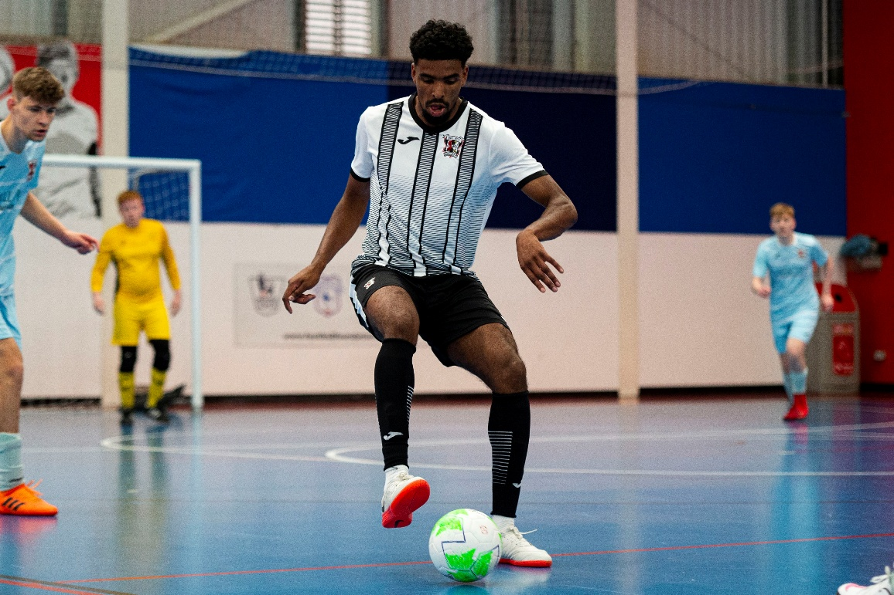

Safeguarding adults’ legislation gives the lead role for adult safeguarding to the Local Authority. However, it is recognised that safeguarding can involve a wide range of organisations.

Sports bodies may need to cooperate with the Local Authority and the Police including to:

- Provide more information about the concern you have raised.
- Provide a safe venue for the adult to meet with other professionals e.g. Police/Social Workers/Advocates.
- Attend safeguarding meetings.
- Coordinate internal investigations (e.g. complaints, disciplinary) with investigations by the police or other agencies.
- Share information about the outcomes of internal investigations.
- Provide a safe environment for the adult to continue their sporting activity/ their role in the organisation.



Section 3: Appendices

Appendix 1 – FAW Safeguarding Team

The FAW Safeguarding Team has primary responsibility for putting into place procedures to safeguard adults at risk, supporting area, league and club safeguarding leads, where relevant and for managing concerns about adults at risk.
Duties and responsibilities include:
- Working with others within the organisation to create a positive inclusive environment within the sport.
- Play a lead role in developing and establishing the organisation’s approach to safeguarding adults and in maintaining and reviewing the organisation’s implementation plan for safeguarding adults in line with current legislation and best practice.

- Coordinate the dissemination of the safeguarding adult policy, procedures and resources throughout the organisation.
- Contribute to ensuring other policies and procedures are consistent with the organisation’s commitment to safeguarding adults.
- Advise on the organisation’s training needs and the development of its training strategy.
- Receive reports of and manage cases of poor practice and abuse reported to the organisation – including an appropriate recording system.
- Support the chair to co-ordinate the case management process.
- Manage liaison with, and referrals to, external agencies for example adult social-care services and the police.
- Create a central point of contact for internal and external individuals and agencies concerned about the safety of adults within the organisation.
- Provide advice and support to League, Area and Club Safeguarding Officers and provide guidance on recruitment, selection and training.
- Represent the organisation at external meetings related to safeguarding.

Appendix 2 – FAW Safeguarding Panel

The FAW Safeguarding Panel comprise of a select number of individuals with identified and relevant skills, knowledge experience and/or status within the organisation and include at least one member with safeguarding adult expertise. The Panel is chaired by an independent legally qualified person. The Panel’s role and decision-making powers are embedded within the organisation’s governance structure and are linked to related organisational functions such as codes of conduct, and the disciplinary policy and procedures.
The senior management team and FAW Board receive regular reports from the FAW Safeguarding Team on the outcome of cases considered by the Safeguarding Panel and the FAW Case Management working group. These reports summarise the cases that have been addressed and their outcomes, as well as any issues that require action by the FAW e.g. changes to policy or procedures.
The Safeguarding Panel has clear Regulations in place and meet regularly or can be brought together as the need arises.
The Safeguarding Panel roles include:
- to make decisions on cases referred to it by the FAW Safeguarding Team and their working group; and
- to make decisions on the continuation or otherwise of an interim suspension order referred to it by the FAW Safeguarding Team and their working group.
Membership includes:
- The Panel consists of no less than three persons, one of which will be drawn from a list of independent chairpersons nominated by the Directors from time to time. The other two Panel members shall be drawn from the following:

- A FAW Board Member
- The FAW Board Advisor on Safeguarding
- A member of the FAW Senior Leadership Team
- A FAW Head of Department or Senior Manager
- An independent member involved in sport but external to football
- An independent member with child protection background

Appendix 3 – Sources of Information and Support

Action on Elder Abuse
A national organisation based in London. It aims to prevent the abuse of older people by raising awareness, encouraging education, promoting research and collecting and disseminating information.
Tel: 020 8765 7000
Email: enquiries@elderabuse.org.uk
www.elderabuse.org.uk

Ann Craft Trust (ACT)
A national organisation providing information and advice about adult safeguarding. ACT have a specialist Safeguarding Adults in Sport and Activity team to support the sector
Tel: 0115 951 5400
Email: Ann-Craft-Trust@nottingham.ac.uk
www.anncrafttrust.org

Men’s Advice Line
For male domestic abuse survivors
Tel: 0808 801 0327

National LGBT+ Domestic Abuse Helpline
Tel: 0800 999 5428

National 24Hour Freephone Domestic Abuse Helplines

Wales
Llinell Gymorth Byw HebOfn/ Live free from fear helpline
Tel: 0808 8010 800
Type Talk: 18001 0808 801 0800
Text: 078600 77 333

Rape Crisis Federation of England and Wales
Rape Crisis was launched in 1996 and exists to provide a range of facilities and resources to enable the continuance and development of Rape Crisis Groups throughout Wales and England.
Email: info@rapecrisis.co.uk
www.rapecrisis.co.uk

Respond
Respond provides a range of services to victims and perpetrators of sexual abuse who have learning disabilities, and training and support to those working with them.
Tel: 020 7383 0700 or
0808 808 0700 (Helpline)
Email: services@respond.org.uk
www.respond.org.uk

Stop Hate Crime
Works to challenge all forms of Hate Crime and discrimination, based on any aspect of an individual’s identity. Stop Hate UK provides independent, confidential and accessible reporting and support for victims, witnesses and third parties.
24 hours service:
Telephone: 0800 138 1625
Web Chat: www.stophateuk.org/talk-to-us/
E mail: talk@stophateuk.org
Text: 07717 989 025
Text relay: 18001 0800 138 1625
By post: PO Box 851, Leeds LS1 9QS

Susy Lamplugh Trust
The Trust is a leading authority on personal safety. Its role is to minimise the damage caused to individuals and to society by aggression in all its forms – physical, verbal and psychological.
Tel: 020 83921839
Fax: 020 8392 1830
Email: info@suzylamplugh.org
www.suzylamplugh.org
Victim Support
Provides practical advice and help, emotional support and reassurance to those who have suffered the effects of a crime.
Tel: 0808 168 9111
www.victimsupport.com
Women’s Aid Federation of England and Wales
Women’s Aid is a national domestic violence charity. It also runs a domestic violence online help service.
www.womensaid.org.uk/information-support

Dewis Cymru
Dewis Cymru is the online directory for wellbeing and support services across Wales. It provides access to information and resources to help people take control of their well-being, including support for children, families, safeguarding, and mental health.
www.dewis.wales

The Ann Craft Trust
Centre for Social Work,
University of Nottingham
Nottingham,
Nottinghamshire,

NG7 2RD Tel. 0115 951 5400

