
Document approved by: FAW Board
Date Policy approved: 27/05/25
Next review Date:28/05/26

Version | Date | Description of Changes/collaboration | Author/Editor | Date sent back
1.0 | 12/03/25 | Created | Natalie Chamberlain (Senior Safeguarding and Player Welfare Manager) | N/A
2.0 | 12/04/25 | Sent to legal Counsel for feedback | Nick Lewis | 14/04/25
1.0 | 12/04/25 | Sent to Senior Equality, Diversity, Inclusion & Sustainability Manager for feedback | Jason Webber  Carys Ingram | 08/05/25
1.0 | 12/04/25 | Sent to Grassroots and Disability Inclusion Manager for feedback | Dai Carpenter | 10/05/25
1.0 | 12/04/25 | Sent to Jodi Evans Anne Craft Trust – verbal feedback face to face meeting – change Adults and Risk to Adults | Jodie Evans | 7/5/25
2.0 | 15/5/25 | Sent to Gaynor McKeown Independent Safeguarding Advisor to the Board | Gaynor McKeown | 15/5/25
2.0 | 27/05/25 | Approved by the Board | FAW Board | 27/05/25

Contents

Introduction 3
Glossary 3
Section 1: Reporting concerns for everyone 5
Reporting Concerns About Others (Flowchart 1) 6
Responding to a Direct Disclosure 8
Record Keeping 9
Section 2: What happens next? 10
(Club Safeguarding Lead and FAW Response) 10
Immediate Response 12
Section 3: Appendices 17
Appendices 17
Appendix 1 - Safeguarding Adults Report Form 17
Appendix 2 – Sources of Information and Support 22

Introduction
The Football Association Wales (FAW) is committed to providing a safe environment for everyone to participate in our organisation and its activities. These procedures must be followed in any circumstances where an adult is at risk of harm.
The procedure should be implemented with reference to the FAW Safeguarding Adults Policy and supporting information.
This procedure details the steps to be taken in responding to any concern that an adult involved in the FAW, or its activities, is at risk of or is experiencing harm.
The procedures have two main sections:
Section 1: Reporting concerns- For everyone.
Section 2: What happens next – For the Club Safeguarding Officer, Club, League and Area Association and the organisational response.
The information is presented in flow charts with accompanying text. Please refer to both as the text contains more detail.

Glossary
For more details, please see the additional information sections of the FAW Safeguarding Adults Policy.
Adult | A person over the age of 18
Adult at risk | Definition used in legislation (different in each home nation) for adults who the Local Authority has a responsibility to support to prevent them from experiencing (further) harm caused by abuse and neglect.
Abuse | A violation of a person’s physical, emotional or mental integrity by any other person.
Case Management Working Group and the Safeguarding Panel | A group created by a sports organisation to ensure the organisation carries out its role/s in individual cases of abuse or neglect AND to maintain an overview of the implementation of the organisation’s safeguarding functions.
Harm | Damage done to a person’s well-being.
MASH | Multi-Agency Safeguarding Hubs are used as a one point of contact/safeguarding referrals in some areas. Where they exist a referral to MASH benefits from the information held by and the expertise of various agencies e.g. Local Authority, Police and Health.
Mental Capacity | The ability to consider relevant information, make and communicate a decision.
Safeguarding | Work to prevent and to stop abuse and neglect.
Safeguarding Adult Team | A team set up to manage the safeguarding of adults at risk within an organisation or more commonly across a Local Authority district.
Safeguarding Adults Board (SAB) (England and Wales) | A statutory body set up in line with national legislation. Statutory membership includes the Local Authority, Police and NHS. Representatives from the voluntary sector and of ‘citizens’ e.g. a representative from a disabled people’s forum are often also included. Their role is to coordinate safeguarding work across the Local Authority district.
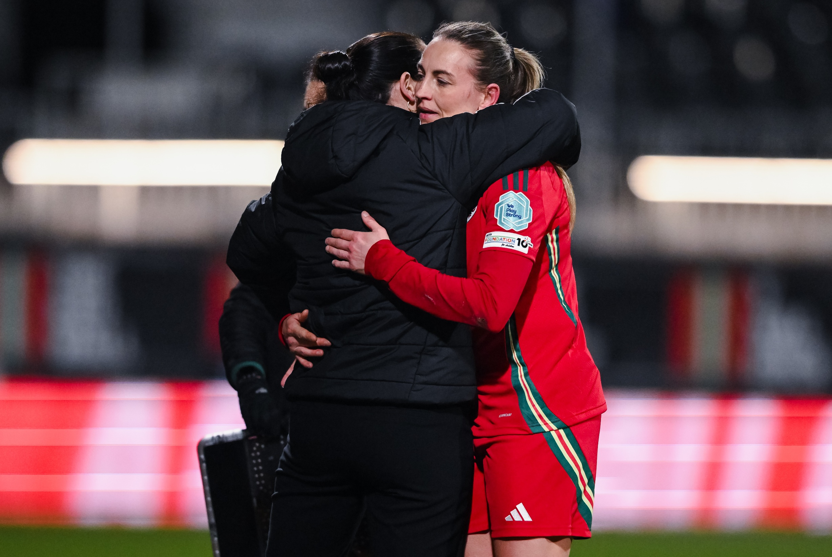

Section 1: Reporting concerns for everyone

Reporting Concerns About Yourself
If you are experiencing harm, contact your Club, League or Area Association Safeguarding Officer. They are there to help keep you safe. They will let the FAW Safeguarding Team know however you must ring 999 if you are in danger.
If you are in immediate danger or need immediate medical assistance, contact the emergency services by telephoning 999.
Please contact the Club Safeguarding Officer. If you would prefer, please contact another member of staff who will help you raise the issue to the Safeguarding Officer.
If the Safeguarding Officer is implicated or you think has a conflict of interest, then report to someone else at the Club who is more senior.
You can also contact the Police, Social Services, your doctor or other organisations that can provide information and give help and support (see Appendix 2 Other sources of support).
The Club will follow the procedure in this document. If you do not think your concerns are being addressed in the way that they should be please contact the FAW Safeguarding Team. Please be aware that this team works Monday to Friday between 9am and 5pm so it is important that you speak to someone who will help you when you need it.
FAW Safeguarding Team – 029 2043 5830 safeguarding@faw.cymru
At all stages you are welcome to have someone who you trust support you and help you to explain what happened and what you want to happen.
It is of upmost importance that you can take part in your football activities safely and we will take every step to support you to do that.

Reporting Concerns About Others (Flowchart 1)
Speak to your Club Safeguarding Officer or FAW Safeguarding Team and report your concerns without delay.
If you have concerns that they are implicated or may make sure you contact the FAW Safeguarding Team
Is a serious crime in progress or been committed?

Contact the police
999.
Yes
No
Seek medical attention or contact emergency services 999.
Yes
You have a concern, or have been told about, abuse of someone else, poor practice or wider welfare issues.
Is the person in immediate danger or need immediate medical attention?
No
Is it safe to speak with the adult?
What does the adult want to happen?
If you know their views include those throughout the process.

Make notes and complete a Safeguarding Adults Concerns Report Form (see Appendix 1), submit to the Club Safeguarding Officer and make sure they send it to the FAW Safeguarding Team. They have 24 hours to let the FAW Safeguarding Team know.

Reporting Concerns About Others
You may be concerned about harm to another person because of something you have seen or heard, information you have been told by others or because someone has confided in you about things that are happening or have happened to them.
You should not keep safeguarding concerns to yourself. If you have concerns and/ or you are told about possible or alleged abuse, or wider welfare issues you must contact your Club Safeguarding Officer as soon as you can. They will let the FAW Safeguarding Team know within 24hrs.
If the Club Safeguarding Officer is implicated or you think has a conflict of interest, then report to the FAW Safeguarding Team
Clubs must adopt Codes of Conduct as part of their commitment to promote good practice and behaviour at the club. There should be separate Codes of Conduct available for Players, Coaches, Managers & Volunteers. Breaches will be dealt with under the Club’s Complaints and Disciplinary Procedures and may be subject to sanctions from the Area Association or the FAW in more serious circumstances.
If you are concerned about harm being caused to someone else, please follow the guidance below.
- It is not your responsibility to prove or decide whether an adult has been harmed or abused. It is, however, everyone's responsibility to respond to and report concerns they have.
- If someone has a need for immediate medical attention call an ambulance on 999.
- If you are concerned someone is in immediate danger or a serious crime is being committed, contact the police on 999 straight away. Where you suspect that a crime is being committed, you must involve the police.
- Remember to be person centred/make safeguarding personal. If it will not put them or you at further risk, discuss your safeguarding concerns with the adult and ask them what they would like to happen next. Inform them that you have to pass on your concerns to your Safeguarding Lead or Welfare Officer. Do not contact the adult before talking to your Safeguarding Lead or Welfare Officer if the person allegedly causing the harm is likely to find out.
- Remember not to confront the person thought to be causing the harm.

Responding to a Direct Disclosure

If an adult indicates that they are being harmed or abused, or information is received which gives rise to concern, the person receiving the information should:
- Take it seriously.
- Stay calm.
- Listen carefully to what is said, allowing the adult to continue at their own pace,
- Be sensitive.
- Keep questions to a minimum, only ask questions if you need to identify/ clarify what the person is telling you.
- Reassure the person that they have done the right thing in revealing the information.
- Ask them what they would like to happen next.
- Explain what you would like to do next.
- Explain that you will have to share the information with the Club Safeguarding Officer.
- Ask for their consent for the information to be shared outside the organisation.
- Make an arrangement as to how you/the Club Safeguarding Officer can contact them safely.
- Help them to contact other organisations for advice and support (e.g. Police, Domestic Abuse helpline, Victim Support -see Appendix 6).
- Act swiftly to report and carry out any relevant actions.
- Record in writing what was said using the adult’s own words as soon as possible.
It is important not to:
- Dismiss or ignore the concern.
- Panic or allow shock or distaste to show.
- Make negative comments about the alleged perpetrator.
- Make assumptions or speculate.
- Come to your own conclusions.
- Probe for more information than is offered.
- Promise to keep the information secret.
- Make promises that cannot be kept.
- Conduct an investigation of the case.
- Confront the person thought to be causing harm.
- Take sole responsibility.
- Tell everyone.

Record Keeping


- Complete a Safeguarding Adults Report Form (see Appendix 1) and submit to the Club Safeguarding Officer without delay.
- Describe the circumstances in which the concern came about and what action you took/ advice you gave.
- It is important to distinguish between things that are facts, things that have been observed or over-heard and opinions, in order to ensure that information is as accurate as possible.
If someone has told you about the harm or abuse, use the words the person themselves used. If someone has written to you (including by email, message) include a copy with the form.

Be mindful of the need to be confidential at all times.
This information must only be shared with your Club Safeguarding Officer and others that have a need to know –e.g. to keep the person safe whilst waiting for action to be take

Section 2: What happens next?

(Club Safeguarding Lead and FAW Response)

Procedure for Club Safeguarding Officer (Flowchart 2)
Steps 1-5 Initial response (as soon as you receive the Safeguarding referral)
Steps 6- 14 Taking Action
Step 3- Person Making the Report
Inform, reassure and advise the person making the report e.g. what to do/what not to do. Explain what will happen next. Reinforce the need for confidentiality.
3
Step 5 – Person at Risk
If it is safe to do so - ensure the person at risk has information about what will happen next.
Make sure they have been given information about other organisations that can support them (see Appendix 2).
Step 4- Person at Risk
What are the risks? What are the views of the adult? Are they an adult at risk? Do they need support to make decisions about their safety?
Do you need to contact the adult directly? Is it safe for you to do so?

Step 2 – Safeguarding Report Details
If you have been sent a Safeguarding Adults Report Form check that you can understand what is written and that all the necessary parts have been completed
If you are being contacted directly request a completed Safeguarding Adults Report Form
(staff and volunteers) or fill in the form with the person making the report (public/adult themselves)

Step 1: Is someone at immediate risk of harm/ danger or in need of immediate medical attention?
NO

If harm is occurring within the club use relevant procedures e.g. breach of code of conduct, Safeguarding Adults Referral to Local Authority if urgent to the FAW to prevent further harm.
YES
Call emergency
services 999.
FAW will liaise with LA who will decide who maintains regular contact with the adult/s who have been at risk of harm.
Step 6 – Consult and Decide – Club Safeguarding Officer
Contact the Local Authority (if needed)/the Police (if needed) and always FAW Safeguarding if there is a safeguarding or welfare concern. Decide which one or more of the following actions need to be taken.

Steps 13 and 14
Recording and reporting
Ensure decisions made, actions taken, and outcomes logged and reported.
Step 7
If a serious crime is suspected contact the police
Referral to FAW Safeguarding (within 24hrs) with the Safeguarding Adults form

Criminal enquiry, investigation, proceedings
Step 8
If you believe there is an ‘adult at risk’ that requires immediate action, make a safeguarding adult’s report to the Local Authority, if immediate action is not necessary make a referral to FAW Safeguarding who will take over this process. If you refer to the Local Authority also refer to FAW Safeguarding
Step 9 If harm is suspected of being caused within a football environment
e.g. by an employee, coach, referee, contracted worker, volunteer or member report to relevant people

Safeguarding adults process
led by Local Authority
Organisation takes short term steps within relevant policy to prevent harm e.g. suspend employee, coach, volunteer or member.
Step 11 – FAW Safeguarding
Take advice from and coordinate actions with other agencies. Attend and contribute to Safeguarding Adults strategy meetings
Step 12
Hold an emergency Internal Multi-Disciplinary Meeting and/ or Case Management Working Group meeting to coordinate actions.
Step 10
Consult with and inform the adult.
Possible Outcomes: e.g.
- Adult receives information about the process.
- Adult supported to have their views and experience heard.
- Adult supported to gain support from other agencies.
- Adult continues to participate in organisation/sport.
Possible outcomes: e.g.

- Referral to FAW Safeguarding Panel
- Informal resolution
- Education and training
- Formal warning
- Dismissal
- Role conditions applied.
- Contract ended.
- Interim or full suspension
- Referred to Independent Barring Board
- Unsubstantiated – no further action
Possible outcomes: e.g.

- Criminal Caution or Conviction
- Police referral back to organisation
- Referral to Independent Barring Board
- Unsubstantiated– no further action
Possible outcomes e.g.

- LA enquiries triggered.
- Adult supported to ‘make safeguarding personal’.
- Other adults at risk identified.
- Multi-agency meetings to coordinate actions.
- New/changed care and support and protection plan for any adult at risk.
- NOT an adult at risk – information and advice provided.

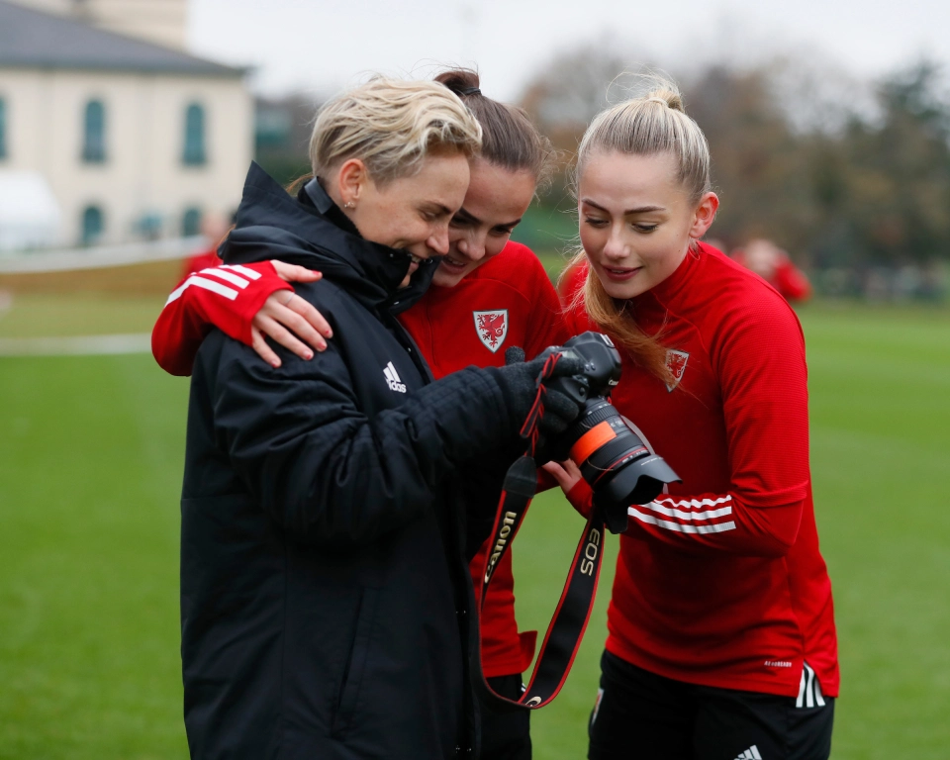

Once a concern has been passed to the FAW Safeguarding Team, they will coordinate the Safeguarding Adults Procedure (see Flowchart 2).
The FAW Safeguarding Team will keep clear records of decision making, actions taken, and the outcomes achieved. They will also collect feedback from the adult.
The FAW Safeguarding Team, where appropriate, in consultation with the Case Management Working Group, will take the following actions:
Immediate Response
- Ensure any immediate actions necessary to safeguard anyone at risk have been taken.
If the risk is said to be due to the behaviour of an employee or other person involved in the organisation/activities use the relevant procedures (e.g. breach of code of conduct, breach of contract, disciplinary or grievance procedures) to prevent that person making contact with the adult being harmed.
- If you have been sent a Safeguarding Adults Report Form check that you can understand what is written and that all the necessary parts have been completed.
If you are being contacted directly by a member of staff or a volunteer request that they complete a Safeguarding Adults Report Form if they have not already done so (see Appendix 1) as soon as possible.
If the report is being made by the adult themselves or a member of the public fill in the safeguarding report form yourself gaining the details with the person contacting you.
Inform, reassure, and advise the person making the report e.g. what to do/what not to do. Explain what will happen next. Reinforce the need for confidentiality.
- Consider what is known about the situation, what the risks are, what is known of the views of the adult, whether they have given their consent to the report being made and whether they might be considered to be an ‘adult at risk’.
Find out whether the person making the report believes the adult has the mental capacity to make decisions about what safeguarding actions they want to be taken (they are not expected to assess this, only provide their opinion).
Decide if you need to contact the adult to get more information, determine their wishes, or explain what actions you need to take.
- Ensue that the adult has been given information about the process and what will happen next. Ensure that they have been provided with information about other organisations that can support them (see Appendix 2).
ONLY do this if you have a known safe way of contacting them. Taking Action

- In all situations you should ensure those at your club/league/area can act (within their remit) to prevent further harm. This includes supporting the person at risk. Depending on the situation you may need to pass information to and work together with other organisations such as the Police and the Local Authority safeguarding team.
- Consult and Decide
Contact the Local Authority (if needed)/the Police (if needed) and always FAW Safeguarding if there is a safeguarding or welfare concern. Decide which one or more of the following actions need to be taken.
- Contact the police (where the crime took place)
If:
- a serious crime has been committed.
- a crime has been committed against someone without the mental capacity to contact the police themselves.
- the adult has asked you to make a report to the Police on their behalf because they are unable to themselves.
- Make a referral/report to the Local Authority Safeguarding Adults Team or Multi-Agency Safeguarding Hub (MASH) (where the adult lives) if you believe they may be an adult at risk
AND
- the adult appears not to have the mental capacity to make decisions about their own safety and well-being.
- the risk is from a person employed or volunteering in work with adults with care and support needs (including within a sports organisations).
- there are other ‘adults at risk’ (e.g. another family member, another club member or other people using a service).
- the adult at risk lives in Wales or Northern Ireland (no consent required).
- the adult at risk lives in England or Scotland and they have asked you to make a report or have given their informed consent to you making it.
If a child is at risk, you must also make a child safeguarding referral to the Local Authority and FAW safeguarding. This includes all situations where there is domestic abuse within the household where the child lives.
If you are unsure whether or not to make a referral/report you can ask for advice by contacting the Local Authority Safeguarding Adults Team/Multi-agency Safeguarding Hub and discuss the situation with them without disclosing the identity of the adult or the person who may be causing harm. You can also contact FAW Safeguarding (Monday – Friday office hours).
- Use policy and procedures to stop harm within the organisation
If the person who may be causing harm is a person involved at the Football club in whatever capacity inform a more senior person at the club. If in doubt, contact FAW Safeguarding.
Decide what policy and procedures the organisation will use to decide which actions will be taken e.g. breach of code of conduct, disciplinary procedures, breach of contract.
Agree what short term arrangements can be put in place to enable the adult, who may be being harmed, to be able to continue participating in the organisation/their sport.
The arrangements made must respect the rights of the person who may be causing harm and must be consistent with the relevant policy and procedures.
- If statutory agencies are involved work together with them to agree the next steps. E.g. the Police may need to interview an employee before a disciplinary investigation is conducted.
Attend and contribute to any safeguarding adult’s strategy or case meetings that are called by the Local Authority.
If statutory agencies say that they will not be taking any action in relation to a referral this should not stop the FAW Safeguarding Team taking internal steps to safeguard the adult. E.g. the Police may decide not to pursue a criminal investigation where there is an allegation against a volunteer, but the organisation should still follow its disciplinary procedure.
These actions can include:
- Referral to the Safeguarding Panel with Independent representatives
- Use of internal procedures such as breach of code of conduct/disciplinary procedures to address any behaviour that may have caused harm.
- Reporting any employee or volunteer found to have caused harm to the Disclosure and Barring Service.
- Communication with the adult about the safeguarding process,
offering support to the adult and making any arrangements needed for them to continue their involvement with the organisation/sport.
- Offering support to staff, volunteers and members affected by the circumstances.
- Ensuring senior managers will are updated as needed.

- Decide who in the organisation will maintain contact with the adult to consult with them, keep them informed and make sure they are receiving the support they need.
Unless advised not to by the Police or Local Authority, and only if there is a safe way to do so, contact the adult to let them know about the actions you have taken and the outcomes so far. Find out if the actions taken are working, what matters to them, what they would like to happen next and what outcomes they want to achieve.
- The FAW Safeguarding Team will hold an emergency Internal Multi-Disciplinary Meeting and/ or Case Management Working Group meeting to coordinate actions:
- share information about what has happened and determine who have a role in safeguarding the adult.
- share the views of the adult.
- share any actions being taken by the Police/Local Authority.
- agree who will coordinate with the and other agencies.
- decide and coordinate what actions they will take.
- Case Management Working Group and Safeguarding Panel meetings must be recorded so that decision making is transparent, and actions agreed are followed. Follow up meetings should be held as necessary until the actions needed are complete.
- Ensure records are complete and stored securely. Collate monitoring information, including feedback from the person who was at risk of harm and report to senior management team/ the Board as requested.

Section 3: Appendices

Appendices

Appendix 1 - Safeguarding Adults Report Form
To be completed as fully as possible if you have concerns regarding an adult.
If it is safe to do so, it is important to inform the adult about your concerns and that you have a duty to pass the information onto the safeguarding lead. The Safeguarding Lead will then look at the information and start to plan a course of action.
Section 1 – Details of adult (you have concerns about)
Name of adult
Address
Date of Birth/ Age
Contact number
Emergency contact if known
Consent to share information with emergency contact?
Section 2 – Details of the person completing this form/ Your details
Name
Contact phone number(s)
Email address
Line manager or alternative.
contact
Name of organisation / club
Your Role in organisation
Section 3 – Details of concern
Please explain why you are concerned. Please give details about what you have seen/been told/other that makes you believe the adult is at risk of harm or is being abused or neglected (include dates/times/evidence from records/photos etc.)

Date/ Time | What happened
Section 5 – Details of the person thought to be causing harm (if known)
Name

Address

Date of Birth/Age
Relationship/connection to adult
Role in organisation

Do they have contact with other adults at risk in another capacity? E.g. in their work/family/as a volunteer
Section 6 - Have you discussed your concerns with the adult? What are their views,
What have they stated about what they want to happen and what outcomes they want?
Section 6A – Reasons for not discussing with the adult
Discussion would put the adult or others at risk. Please explain:

Adult appears to lack mental capacity. Please explain:
Adult unable to communicate their views. Please explain:
Section 7 – Risk to others
Are any other adults at risk Yes/No/Not known – delete as appropriate
If yes, please fill in another form answering questions 1-6
Are any children at risk Yes/No/Not known Delete as appropriate
If yes, please fill in a safeguarding children referral form and attach to this.
Section 8 – What action have you taken if any /agreed with the adult to reduce the risks?
Actions by club: e.g. person causing harm suspended, session times changed.
Section 9: Other agencies contacted |  |  | Who contacted/reference number/contact details/advice gained/action being taken
Police
Ambulance
Other – please state who and why:

Section 10: Contact with Welfare Officer/others within the club
Who else has been informed of this issue? – and what was the reason for information sharing

Consultation with Safeguarding Lead |  |  |  | Dates and times
Completed Form copied to Safeguarding Lead; Date and time
Signed:
Date:

OFFICE USE ONLY
Section 11 – Sharing the concerns (To be completed by Safeguarding Lead)
Details of your contact with the adult at risk of harm. Have they consented to information being shared outside of the FAW?
Details of contact with the Local Authority Safeguarding Team/MASH where the adult at risk of harm lives – advice can be still sought without giving personal details if you do not have consent for a referral.

Details of any other agencies contacted:
Details of the outcome of this concern:

Appendix 2 – Sources of Information and Support

Action on Elder Abuse
A national organisation based in London. It aims to prevent the abuse of older people by raising awareness, encouraging education, promoting research and collecting and disseminating information.
Tel: 020 8765 7000
Email: enquiries@elderabuse.org.uk
www.elderabuse.org.uk

Ann Craft Trust (ACT)
A national organisation providing information and advice about adult safeguarding. ACT have a specialist Safeguarding Adults in Sport and Activity team to support the sector.
Tel: 0115 951 5400
Email:Ann-Craft-Trust@nottingham.ac.uk
www.anncrafttrust.org

Men’s Advice Line
For male domestic abuse survivors
Tel: 0808 801 0327

National LGBT+ Domestic Abuse Helpline
Tel: 0800 999 5428

Dewis Cymru
Dewis Cymru is the online directory for wellbeing and support services across Wales. It provides access to information and resources to help people take control of their well-being, including support for children, families, safeguarding, and mental health.
www.dewis.wales
National 24Hour Freephone Domestic Abuse Helplines

Wales
Llinell Gymorth Byw HebOfn/ Live free from fear helpline
Tel: 0808 8010 800
Type Talk: 18001 0808 801 0800
Text: 078600 77 333

Rape Crisis Federation of England and Wales
Rape Crisis was launched in 1996 and exists to provide a range of facilities and resources to enable the continuance and development of Rape Crisis Groups throughout Wales and England.
Email: info@rapecrisis.co.uk
www.rapecrisis.co.uk

Respond
Respond provides a range of services to victims and perpetrators of sexual abuse who have learning disabilities and training and support to those working with them.
Tel: 020 7383 0700 or
0808 808 0700 (Helpline)
Email: services@respond.org.uk
www.respond.org.uk

Stop Hate Crime
Works to challenge all forms of Hate Crime and discrimination, based on any aspect of an individual’s identity. Stop Hate UK provides independent, confidential and accessible reporting and support for victims, witnesses and third parties.
24 hours service:
Telephone: 0800 138 1625
Web Chat: www.stophateuk.org/talk-to-us/
E mail: talk@stophateuk.org
Text: 07717 989 025
Text relay: 18001 0800 138 1625
By post: PO Box 851, Leeds LS1 9QS

Susy Lamplugh Trust
The Trust is a leading authority on personal safety. Its role is to minimise the damage caused to individuals and to society by aggression in all its forms – physical, verbal and psychological.
Tel: 020 83921839
Fax: 020 8392 1830
Email: info@suzylamplugh.org
www.suzylamplugh.org
Victim Support
Provides practical advice and help, emotional support and reassurance to those who have suffered the effects of a crime.
Tel: 0808 168 9111
www.victimsupport.com
Women’s Aid Federation of England and Wales
Women’s Aid is a national domestic violence charity. It also runs a domestic violence online help service.
www.womensaid.org.uk/information-support

The Ann Craft Trust
Centre for Social Work,
University of Nottingham
Nottingham,Nottinghamshire, NG7 2RDTel. 0115 951 5400

